Asian Development Bank | Government of Vietnam  Ministry of Natural Resources  and Environment

TA7629-VIE: Capacity Building for River Basin Water Resources Planning
Component 2: Planning Tasks for the Red-Thai Binh River Basin

Water Indicators for the Red -Thai Binh River Basin:
The Indicators and Their Use

Prepared for:
The Department of Water Resources Management on behalf of the Government of Viet Nam and the Asian Development Bank

Prepared by
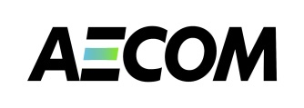
AECOM Asia Co. Ltd.

April 2012
Acknowledgments
This component of CDTA 7629-VIE: Capacity Building for River Basin Water Resources Planning supports the Ministry of Natural Resources and Environment in undertaking activities related to the preparation of planning tasks for the management of water resources of the Red-Thai Binh river basin. Planning tasks are prescribed in the revised Law on Water Resources and precede the formulation of a Water Resources Plan. Planning tasks make prioritised recommendations and a framework for the preparation of river basin planning. The CDTA also aim to develop and pilot a cost-effective framework for formulating planning tasks that could be replicated in other basins of Viet Nam.
The contributions to this report are acknowledged: Des Cleary (Water Basin Planning Expert (International), who led the preparation of the report), Ms. Nguyen Thi Phuong Lam (Deputy Team Leader) and Dr. Eric Biltonen (TA Team Leader, lead editor and finalization).
Limitations Statement
The sole purpose of this report and the associated services performed by AECOM is to set out draft guidelines for the preparation of a status report as part of undertaking river basin planning tasks as set out in Decree 120.2008; and in accordance with the scope of services set out in the contract between AECOM and ADB.
AECOM’s consultant prepared this report primarily based on the Terms of Reference provided by the ADB and an inception report prepared by consultants engaged by the ADB to lead the TA. The passage of time may require re-evaluation of the findings, proposals and conclusions expressed in this report.
No warranty or guarantee, whether express or implied, is made with respect to the information reported or to the findings, observations and conclusions expressed in this report. Further, such information, findings, observations and conclusions are based solely upon information in existence at the time of report preparation.

TA7629-VIE: Capacity Building for River Basin Water Resources Planning
Component 2: Planning Tasks for the Red-Thai Binh River Basin

Water Indicators for the Red-Thai Binh River Basin:
The Indicators and Their Use

Table of Contents

1. INTRODUCTION 5
2. The indicators 6
3. SURFACE WATER RESOURCES INDICATORS 8
3.1 Water Distribution Indicators 8
3.2 Dry Season Water Indicator 10
3.3 Effects of the Dry Season on water resources 10
3.4 Effects of infrastructure – dams and inter-basin diversions 12
Data sources and comments 15
Water Availability Indicators 15
3.6 Water Exploitation Indicators 18
Data sources and comments 21
3.7 Flood Indicator 22
3.8 Climate change Indicators 22
4. Groundwater Indicators 23
4.1 Explanation of groundwater indicators 23
5. Social Development Indicators 31
5.1 Population Indicators 31
5.2 Poverty and employment indicators 34
Data sources and comments 36
5.3 Water related services indicators 37
Data sources and comments 39
5.4 Water related disaster indicators 39
Data sources and comments 40
6. Economic Indicators 40
6.1 GDP Indicators 40
Data sources and comments 42
6.2 Sub-sector economic indicators 43
Data sources and comments 46
7. Environmental indicators 47
7.1 Conservation and land use indicators 47
Data sources and comments 49
7.2 Water flow indicators 50
Data sources and comments 52
7.3 Water quality indicators 52
Data sources and comments 56
8. Water Management Indicators 57
8.2 Basic survey indicators 58
Sources of data 60
8.2 Licensing indicators 60
Data sources and comments 62
8.3 Environmental tools indicator 62
Data sources and comments 65
8.4 Efficient service provision indicators 65
Data sources and comments 66
8.5 Capacity indicators 67

ABBREVIATIONS

ADB |  | Asian Development Bank
DoNRE |  | Department of Natural Resources and Environment (Provincial)
DWRM |  | Department of Water Resources Management (MoNRE)
EIA |  | Environmental Impact Assessment
EVN |  | Electricity Viet Nam
GDP |  | Gross Domestic Product
GSO |  | General Statics Office (of Viet Nam)
GWh |  | Gigawatt hour
HCMC |  | Ho Chi Minh City
IWRM |  | Integrated Water Resources Management
MARD |  | Ministry of Agriculture and Rural Development
MDG |  | Millenium Development Goals
MoC |  | Ministry of Construction
MoH |  | Ministry of Health
MoLISA |  | Ministry of Labour, Invalids, and Social Affairs
MoNRE |  | Ministry of Natural Resources and Environment
NGO |  | Non-Government Organisation
NWRC |  | National Water Resources Council
RTBRB |  | Red-Thai Binh River Basin
SoE |  | State of Environment
TA |  | Technical Assistance
VEA |  | Viet Nam Environment Administration (MoNRE)
VND |  | Vietnamese Dong
VWSA |  | Viet Nam Water Supply and Sewerage Association
WASECO |  | Water Supply and Sewerage Companies
WHO |  | World Health Organization
WSR |  | Water Sector Review

TA7629-VIE: Capacity Building for River Basin Water Resources Planning
Component 2: Planning Tasks for the Red-Thai Binh River Basin

Report on Water Resources Indicators for the for the Red-Thai Binh River Basin

1. INTRODUCTION
This reports sets out the results of the application of a set of indicators in preparing a strategic and consistent analysis of the Red-Thai Binh River Basin (RTBRB), as a basis for the preparation of Planning Tasks.
Planning Tasks are established under Article 20 of the Law on Water Resources 2012, and are to be undertaken as a rapid assessment of the river basin prior to more detailed river basin planning activities. They are an important element of the overall water resources planning framework and are undertaken as a first step to set the scene for more detailed river basin planning. Planning Tasks concentrate on high level issues, objectives, and solutions. Planning tasks will:
- Identify agreed water functions of water sources and objectives - what are the broad objectives that river basin planning should achieve;
- Identify priorities for activities - what are the issues and the key areas in which management activities are required. Examples of issues that may be included are: dealing with water shortages, pollution control, flood mitigation, protection of the stability of the river channel structure, or groundwater management for a specified area;
- Propose general solutions - what needs to be done to achieve the objectives. Principally this will involve specifying activities for subsequent river basin planning – in effect, setting ‘terms of reference’ for the river basin planning. As well, more immediate general solutions may be proposed - such as the need for a community awareness campaign, or for capacity building, or for research or specific monitoring. Detailed measures will be identified in the water resources plans for river basins.
Planning tasks should set both long term outcomes for the river basin (vision, water sources functions and objectives), and also 5 year targets for overall water management. This is based on a principle of continuous improvement in water resources management, and in the social and economic benefits the community receives from its water sources and their dependent ecosystems.
A Status Report for the RTBRB will be prepared as a basis for the identification of issues and options for the Planning Tasks. The Report will provide a status summary of the water resource and management of the river basin. The challenge for those preparing the Status Report is to achieve the balance between providing sufficient information for sound decision making for the Planning Tasks, without going into excessive detail. The main aim of Planning Tasks is to prepare “terms of reference” for the preparation of a water resources planning activity for a river basin – not to do the detailed analysis at this early stage.
A key component for formulating the Planning Tasks is the development of the Status Report. The status report provides a status summary of the key water resource and management issues for river basin. The main aim of Planning Tasks is to prepare “terms of reference” for the preparation of a water resources planning activity for a river basin as relevant to MoNRE’s management function, but not to do a comprehensive, detailed analysis. That is, the status report provides the framework for the in-depth river basin planning
The assessment indicators allow for a systematic analysis of key issues in each sub-basin, as well as allow sub-basin comparisons and progress tracking over time. The indicators allow a uniform analysis across sub-basins. These guidelines focus on the calculation and interpretation of a set of Assessment Indicators that provide the bulk of that analysis for the status report.
These Planning Tasks provide the framework for the full water resources planning for river basins. The river basin planning is necessary so that water resources are effectively managed for the mutual benefit of all stakeholders. This is especially necessary when water resources are not available in sufficient quantities and quality to meet all demands. Planning provides water resource policy decision makers and managers to make well-informed decisions to meet current and future challenges based on the sound information and analysis. Without planning, water management will lack purposeful direction and possibly harm to the people who depend upon the water resources.

2. The indicators
A set of indicators has been developed to assess the basin and sub-basins. The indicators make use of existing available data and information and allow a standardised method of analysis that may be applied in other basins. They may be reapplied in the future to assess progress.
- Water Resources (18 indicators): quantity, international linkages, dry season effects, water use, water storages, flooding effects and climate change effects.
- Groundwater (13 indicators): groundwater recharge, availability, water use, water level drawdown and groundwater quality.
- Economic (12 indicators): GDP, economic structure, sector production (industry, agriculture, irrigation, hydropower, navigation) and economic value for water use.
- Social (13 indicators): population, population structure, poverty, ethnicity, employment, water services (clean water, sanitation), and flood impacts.
- Environment (12 indicators): vegetation cover, biodiversity, conservation areas, cultural heritage areas, natural river flows, water quality, and river obstructions.
- Management (16 indicators): basic survey (surface water, groundwater, water quality, environment, licensing, application of Government decisions (Decision 64, Decree 67), use of EIA, inspections and efficient service provision.
Indicators
The indicators show the current situation along with some future projections. Data and information to calculate the indicators is obtained from a wide range of sources and documents. However, data obtained from the General Statistics Office will form the basis for required data sets, such as population, area, GDP, etc. The data should be as up to date and accurate as possible. For the purpose of undertaking planning tasks, absolute accuracy is not essential, and achieving this would have required significantly more time for data collection and verification. For planning tasks, it is important that the data can illustrate the approximate magnitude of issues and challenges and the relativity of these between the sub-basins.
The Indicators are intended to serve as a policy tool to assist with the strategic analysis of issues that deserve attention within national and provincial water management programs. The indicators also provide a way to identify those sub-basins that are at a critical stage with regard to a particular issue. This is useful in identifying management priorities and can help to guide thinking on what is required to make policy progress.
The indicators provide a useful policymaker’s guide to the status of the water resource and water resource management challenges in the Basin, highlighting where each particular sub-basin might benefit from increased investment and management attention.

For purposes of formulating the planning tasks, the Red-Thai Binh River Basin was sub-divided into five sub-basins: Da, Thao, Lo-Gam, Cau-Thuong, and Red-Thai Binh Delta. The RTBRB receives water inflows from China, but does not pass flows to another country. Within the basin, there are a number of major reservoirs and infrastructure has been built to divert water between sub-basins. Figure 1 depicts the RTBRB.
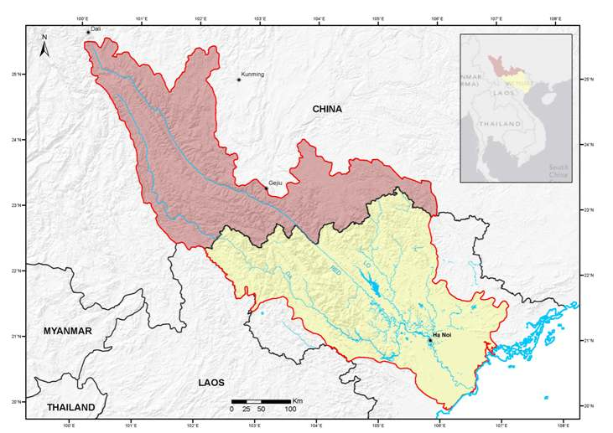
Figure 1. Red-Thai Binh River Basin

3. SURFACE WATER RESOURCES INDICATORS

3.1 Water Distribution Indicators
This section analyses the relative contributions of the different sub-basins to the overall Basin water resources, the total water volume in the sub-basins, their sources of water and the movement of this water. The indicators are designed to show the inter-linkages between international parts of the sub-basins, and the inter-linkages between the sub-basins.
WRI-1 is the Sub-Basin water indicator. This shows the total water volume generated within the sub-basins, as a proportion of the total Basin water volume, including water from any other country. WRI-1a shows the total, including international components, while WRI-1b shows only water generated within Viet Nam.
The results for the RTBRB are presented in the following chart:
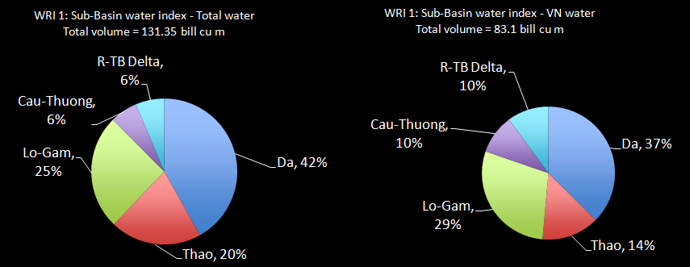
The chart shows that the majority of the water generated within the entire Basin comes from the Da River Sub-basin (42%). The Delta generates relatively little water in its own land area – only 6% to the Basin total water – and relies heavily on inflows from the upper Northern sub-basins for its water. Of the water generated solely within Viet Nam, the Da sub-basin provides 37% and the Lo-Gam 29%.

WRI-2 is the international water Indicator. This is the proportion of the total water resources volume of the sub-basin that (a) comes from another country or (b) flows to another country
This indicator demonstrates: (a) the dependence of the sub-basins on water inflows from another country; and (b) the dependence of other countries on the water from this basin.
The results for the RTBRB are presented in the following chart:
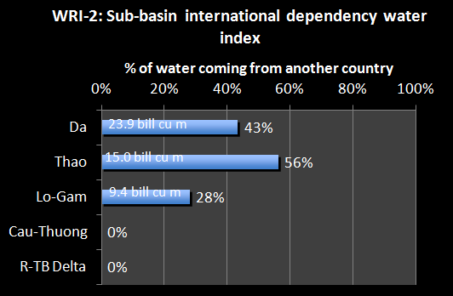
The total average annual surface water volume in the RTBRB is about 131.4 billion m3, including water generated within China. This volume is about 16% of the national water volume. Three of the sub-basins have a significant part of their upstream catchment areas in China and therefore rely on international water inflows – the Da receives 43% of its annual water volume from China, the Thao 56% and the Lo-Gam 44% - as seen in the Chart. Overall, nearly 37% of the Basin water volume is generated outside of the Basin in China. No water flows from the RTBRB to another country.

WRI-3 is the inter-basin discharge indicator. This shows the proportion of the total water resources volume generated in the sub-basin that under current conditions and water use patterns (a) comes from another sub-basin or (b) flows to another sub-basin. For each sub-basin this indicates: (a) the dependence of other sub-basins on the through-flow of water from this sub-basin; and (b) the dependence of this sub-basin on water flowing from another sub-basin.
This indicator demonstrates: (a) the dependence of this sub-basin on water inflows from another sub-basin; (b) the dependence of other sub-basins on the water from this sub-basin. The results for the RTBRB are presented in the following chart:
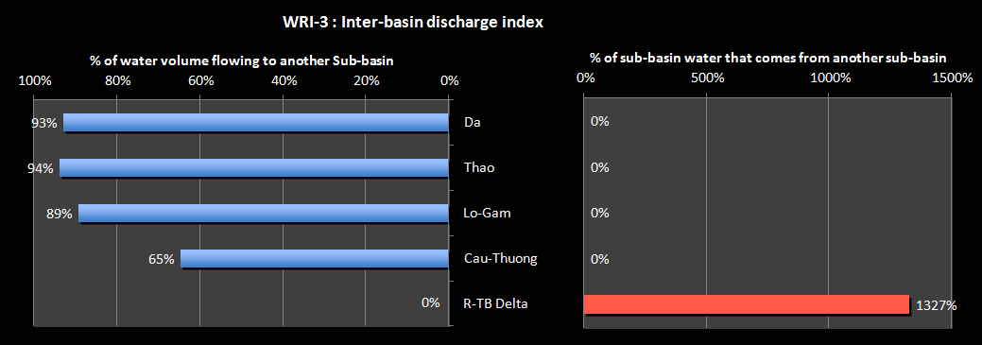

It is estimated that 93% of the water naturally generated in the Da sub-basin is currently not used in that sub-basin and eventually flows naturally to the Delta sub-basin. Similarly, 94% of the Thao water, 89% of the Lo-Gam water and 65% of the Cau-Thuong waters flow naturally to the Delta sub-basin. Together these natural through-flows between the sub-basins increase the surface water in the Delta by over 13.5 times the volume naturally generated within the Delta.

3.2 Dry Season Water Indicator
Viet Nam is marked by a distinct rainy season. This indicator analysis examines how the wet seasons and the dry seasons vary from one part of the Basin to another.

Explanation of Dry Season Water Indicator
WRI-4 is the dry season water Indicator. This is the proportion of the total annual water volume generated in the sub-basin that is generated in the dry season (including water in VN and international inflows). It indicates the proportion of the total water volume that is available in the dry season under natural conditions, and the length of the dry season. It provides an indication of the stress on the sub-basin during the dry season. A small ratio and a large number of months mean that there is very little water available in the sub-basin for a long period. This shows that water shortages will be acute and conflicts over access to water may be significant.
The dry season for the RTBRB lasts for 7 months between November and May. In that period, only 35.5 billion m3 of water is available – just 27% of the total annual water is available. The RTBRB provides 18% of the total National dry season water volume.
The results for the RTBRB are presented in the following chart:
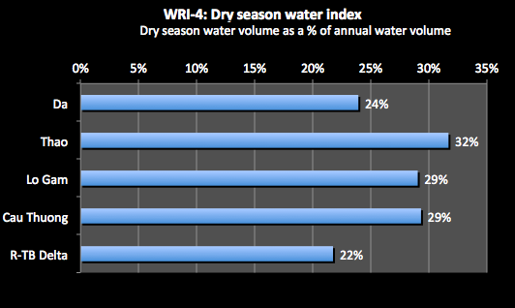
The chart shows that during the long dry season the sub-basins receive only a small proportion of the annual water. The Da receives only 24% of its annual water volumes over those 7 months. The Thao receives the highest proportion, almost a third of its annual water during the dry season. The Delta sub-basin receives only 22% of its natural water over the dry season, but this water is augmented by inflows from the upper sub-basins

3.3 Effects of the Dry Season on water resources
The dry season will have a significant effect on available water resources and water movement within the Basin overall.
WRI-5 is the dry season international water Indicator. This indicator shows the proportion of the dry season water volume of the sub-basin that (a) comes from another country or (b) discharges to another country.
The results for the RTBRB are presented in the following chart:
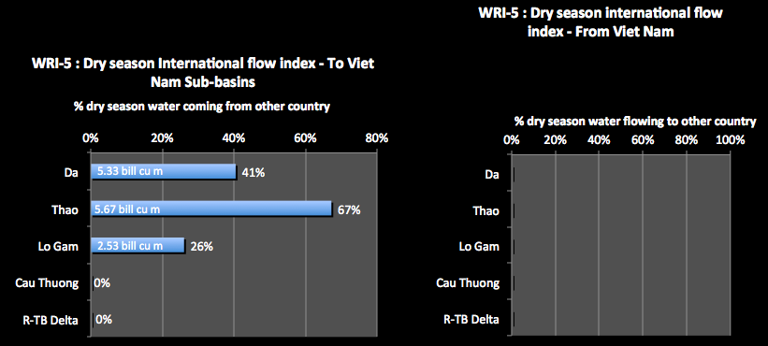
The chart shows (a) the dependence of the sub-basin on water inflows from another country, and (b) the dependence of other countries on the water outflow or discharge from the sub-basin
Over the dry season, 28% of the overall water volume in the Basin comes from China. 67% of the water volume for the Thao sub-basin comes from China and 41% for the Da. This emphasises the importance of establishing agreement with China over water flows and water sharing in order to secure water security.
WRI-6 is the water productivity Indicator. This relates the water volume generated in the sub-basins to the sub-basin areas to determine those areas that are providing the most water to the Basin. This index is calculated for the annual water situation and for the dry season, using naturally generated flows to indicate the natural productivity of the catchments. This is complicated by the fact that sometimes an area may have a high runoff per unit area, but may in fact be contributing relatively little water volume to the basin. Therefore, the indicator also needs to include a weighting that reflects the significance of the water volume the sub-basin produces. The weighting factor is the proportion of the total Basin water produced by the sub-basin.
The result is an index of significance of water productivity. A high number indicates high significance of the sub-basin in terms of water productivity, both annually and in the dry season. These areas are those that need to be protected by catchment management activities to ensure they can continue to generate water into the future. For the purposes of preparing planning tasks, analysis at the sub-basin scale may be quite appropriate. However, for the preparation of a river basin plan dealing with water quantity or water allocation, then analysis at the levels of sub-areas within the sub-basin may be required.
The results for the RTBRB are presented in the following chart:
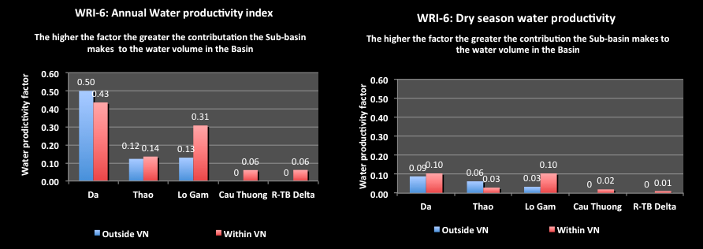
The chart shows the most productive water generating areas of the Basin (in million m³ of water per sq km). In terms of water generated within Viet Nam’s territory, the Da sub-basin is by far the most productive with the Lo-Gam next. The Da has a productivity factor 7 times that of the Delta, where little water is naturally generated. For the area outside of Viet Nam’s territory, the Da is again significantly more productive than the other sub-basins. During the dry season, for the sub-basin areas within Viet Nam, the Da and Lo-Gam are the most productive – over 3 times more than the Thao and the Cau-Thuong. For the dry season, the sub-basin area outside of Viet Nam in the Da is not as highly productive as for the annual water productivity and indeed is less productive than the area within Viet Nam It should be noted that for the annual water productivity, the area with higher productivity likely has higher rainfall, but in the dry season, the area with higher productivity likely has better forest conditions.

3.4 Effects of infrastructure – dams and inter-basin diversions
Previous indicators have looked at the natural situation of water volumes, their occurrence, their natural movement and the effects of the dry season. The next few indicators will demonstrate natural flows have been significantly modified through the construction of dams and reservoirs, the control on river flows offered by those reservoirs, and the diversion of water resources from one river system to another, typically by hydro-power works.

Explanation of the infrastructure indicators – reservoir and inter-basin diversions

WRI-7 is the water storage share indicator. This shows the total active reservoir volume in the sub-basin as a proportion of the total active reservoir volume in the RR Basin, both (a) currently and (b) for 2025. (i) ‘Active storage’ is defined as the full supply level of a reservoir minus the reservoir dead storage. It is the storage volume available for use through the normal operation of the dam. Active storage values should be calculated for existing reservoirs, and those that are currently under construction, with completion expected by within the next 18 months.
The indicator shows the significance of the storage volume of this sub-basin compared to the total basin storage volume.
The RTBRB contains nearly 50% of the total reservoir storage volume in Viet Nam. The chart generated for this indicator is as follows:
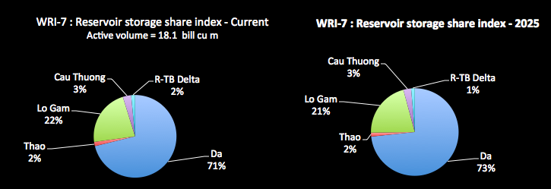
The chart shows that 71% is located in the Da sub-basin (a total of 12.9 billion m³). This proportion is expected to increase into the future as further hydropower reservoirs are built. The current reservoir storage volume in the Da sub-basin is 23% of the annual water volume meaning that on average the reservoir could fill three or four times each year. This figure is 12% for the Lo-Gam, and only a small percentage for the other sub-basins
WRI-8 is the water storage control index for the Sub-Basin. This shows the active reservoir storage in a sub-basin divided by the total water volume for the sub-basin. It gives an indication of the proportion of surface water volume in a basin that can be controlled by the reservoirs. A high ratio means that the reservoirs can exert significant control over river flows. While this may indicate good flood control potential, it may also indicate that river health or the needs of lower river communities may not be met. The results for the RTBRB are presented in the following chart:
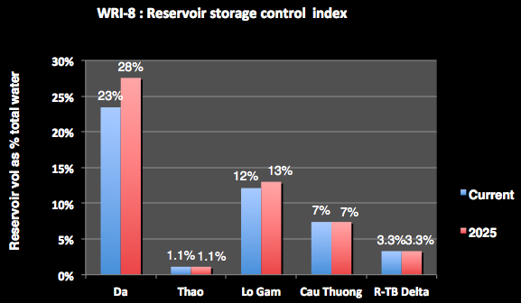
The chart shows that the reservoir storages in the Da sub-basin are a relatively high proportion of the water volumes generated in that sub-basin – 23% at current levels and increasing to 28% by 2025. This means that over a quarter of the flows can be captured and controlled in the reservoirs, a high percentage. The reservoirs of the Lo-Gam can also have a significant effect on the natural river flows.
WRI-9 is the water storage benefit Indicator. This is the proportion of total reservoir active volumes in the sub-basin used solely for hydropower and other single purpose use, such as urban water supply; and the proportion for multi-purpose use. It shows the predominant use of reservoirs in the sub-basin, and the proportion of single purpose storages to multi-purpose storages. A high ratio of single purpose storages means that generally storages are sector based with little integration.
The indicator shows the predominant use of reservoirs in the sub-basin - current and at 2025, and the water storage per capita in sub-basins, which can be compared to international levels.
The indicator also shows the benefits derived from the reservoir storages, and makes a distinction between the storages that add to the water security of the Basin and hydropower storages. Water storages for irrigation or water supply or flood mitigations are all providing water security benefits – additional water supply or protection from water disaster impacts. However, hydropower storages are built and operated primarily to provide energy security to the country. As such, they do not explicitly provide water supply benefits, although these can occur as incidental benefits.
The results for the RTBRB are presented in the following chart:
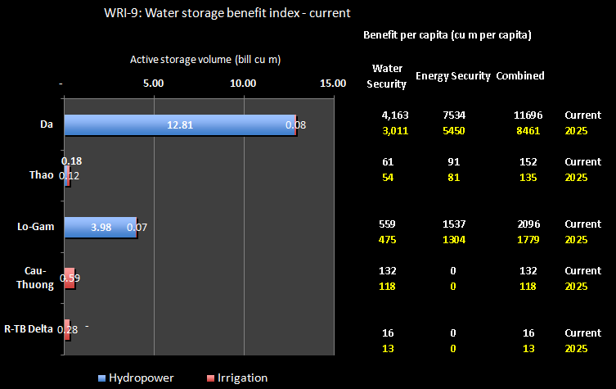
The chart shows that most of the water storage is in the Da sub-basin, resulting in that sub-basin having a very high water storage per capita figure (11,696 m³ per person). However, this is as expected because the overall storages volumes in the sub-basin are very large and the population small. The water security storage volume is also quite high at 4,163 m³, mostly because of the high flood mitigation component of the storages (7 billion m³ – note that this capacity is just the part of the active storage that is allowed to be used for flood mitigation in the wet season). The figures for the Lo-Gam sub-basin are also quite high overall, but the water security figure is only 559 m³ a person. Overall, the indicator shows that the energy security benefits of the reservoirs are much larger than the water security benefits.
WRI-10 is the infrastructure sub-basin inter-diversion Indicator. This is the proportion of the water volume of a sub basin that is diverted by physical water works from a sub-basin into another sub-basin. This is calculated on a total annual basis and for the dry season. Typically these works are for hydropower generation. This indicator seeks to analyse these physical sub-basin inter diversions, and will show where the water is transferred from and the receiving sub-basin(s). A high percent diverted out indicates a significant amount of water no longer available in this sub-basin with consequential impacts on river health and basin communities. These effects can be accentuated in dry times.
The results for the RTBRB are presented in the following chart:

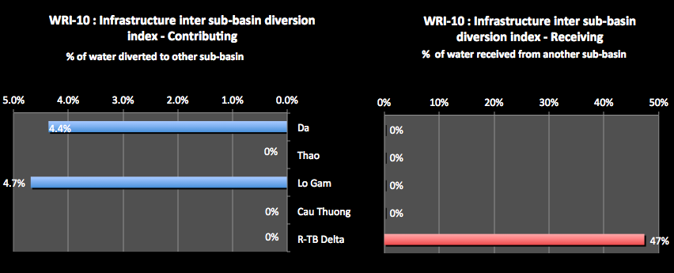
The chart shows the proportion of the sub-basin natural water volume that is diverted from a sub-basin (contributing) or is diverted into another sub-basin (receiving). Both the Da and Lo-Gam divert water to the Delta sub-basin. In both cases, the diversion represents only a small fraction of the water in these basins. However, the water received in the Delta from the diversion amounts to nearly half the water naturally generated in the sub-basins.

Data sources and comments
The following should also be noted with respect to the data used:
- Where water is being transferred from one sub-basin to another by water works infrastructure, the amount transferred during the dry season should be added to the receiving basin, and subtracted from the donor basin. An assumption is made that these infrastructure transfers occur uniformly across the months of the year.
- ‘Active storage’ is defined as the full supply level of a reservoir minus the reservoir dead storage. It is the storage volume available for use through the normal operation of the dam. Active storage values should be calculated for existing reservoirs, and those that are currently under construction, with completion expected by within the next 18 months.
- Active storage volumes need to be obtained from many sources. For example, the MARD Department of Hydraulic Works (covering for more than 400 reservoirs) is a good source.
- Agreement between Ministry of Agriculture and Rural Development (MARD) and Electricity of Viet Nam (EVN) on the Water providing for Winter - Spring crop of Red River Delta 2011–2012. The Plan is based on the real weather situation and planting schedule to make decisions on how much water should be released from Hoa Binh, Thac Ba, and Tuyen Quang reservoirs to meet the irrigation demands downstream. For 2011-2012, 3.950 billion m³ of water was released downstream in two stages.

Water Availability Indicators
The following indicators relate the water resources volumes in the sub-basin to per capita water demand. This is expressed as the water volumes available (cubic metres per person), the uses made of the water for different demands (irrigation, urban, industry, etc.), and the impacts on the water resources from that use.
The international standard for having adequate water per person is 4,000m³ a year, with the possibility remaining of having irregular or local water shortages with annual water availability of between 1,700m³ and 4,000m³. Below 1,700m³/ capita/ year water stress appears regularly; below 1,000m³/capita/year water scarcity is a limitation to economic development; and below 500m³/capita/year water availability is a main constraint to life.
These indicators also consider the dry season water availability, as this is the most critical issue for water management in much of Viet Nam – the availability of water and conflicts over access to water over the long dry seasons. In order to assess the water available in the dry season in the sub-basin, the natural water volumes need to be augmented to take account of:
- The inter basin diversions using the built infrastructure – dams and diversion works.
- The storage volumes in the basin groups. It is assumed that the storages will be full at the end of the wet season, and therefore the water will be available for use during the dry season. Therefore the active storage within each basin should be added to the dry season discharge, with the assumption that all the active storage is used during the dry season. As almost all, if not all, reservoirs are managed on an annual basis (that is, they fill each year, and the full active storage is available for use at the end of the wet season), this assumption appears valid. In reality, the amount of active storage available for the dry season use depends on the management of each reservoir. If reservoirs are managed conservatively to ensure late wet season floods can be effectively mitigated, full supply level may not be achieved if these floods do not eventuate. The ‘dry season’ discharge used in this analysis may, therefore, be slightly over stated.

Explanation of Water Availability Indicators
WRI-11 is the water availability indicator This is the total annual water resources volume generated in the sub-basin divided by: (a) current population (VN only); (b) projected population at 2025 (VN only); As well, for the Delta sub-basin which depends substantially on natural through-flows from other sub-basins, the through flows are included in a separate assessment. This indicator shows the relative abundance of surface water resources for the population of the basin.
The indicator relates the total natural water volume to the population (cu m per capita, current and at 2025) and indicates the ability of the natural water resources to support the population now and into the future (based on current natural water which may decline under climate change).
The results for the RTBRB are presented in the following chart:
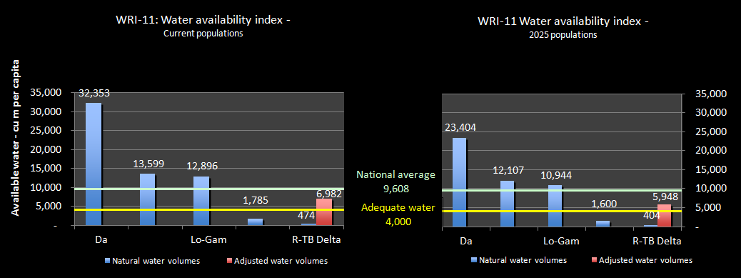
The average surface water availability for the RTBRB is 4,627 m³ per capita, less than half the National average. The chart shows that the Da sub-basin has a water availability of over 32,353 m³ per capita, meaning plentiful water compared to its population. The Thao sub-basin (13,599 m³ per capita) and the Lo-Gam (12,896 m³ per capita) also have bountiful water for its populations. The Cau-Thuong, however, is in an extremely difficult situation with water availability of only 1,785 m³ per capita, meaning that water shortages are already occurring. At projected 2025 populations, the availability figure of this sub-basin would be as low as 1,600 m³ per capita, meaning water availability stress will be increasingly apparent.
The water that is naturally generated in the Delta sub-basin is only 474 m³ per capita. However, this is a fairly meaningless figure, and it must be recognised that the majority of water within the Delta comes from the 4 upper sub-basins, particularly the Da, Thao and Lo-Gam. When the average through-flows from these sub-basins to the Delta are included, the water availability is 6,982 m³ per capita (this is shown as the red column in the chart).
WRI-12 is the dry season water availability Indicator. This index shows the dry season water volumes generated in the sub-basin divided by: (a) current population (VN only); (b) projected population at 2025 (VN only). As well, for any sub-basins the depend substantially on dry season through flows from other sub-basins (such as delta sub-basins) then adjust the dry season volumes by including the through flows, inter-basin diversions and water volumes in reservoir storage in a separate adjusted assessment The analysis is the same as for WRI-11, but using the dry season water availability figures, and comparing those results against the international standards.
The indicator relates the dry season water resources with the population (m³ per capita, current and at 2025) and indicates the ability of the water resources to support the population in the dry season.
The results for the RTBRB are presented in the following chart:
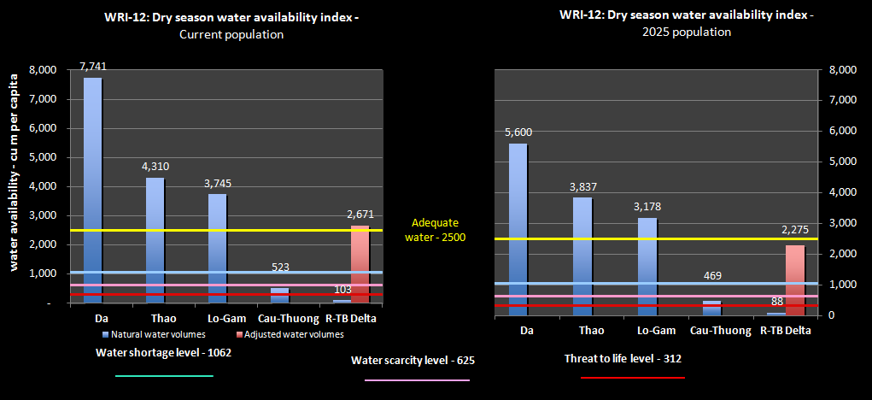
Although consideration of the annual figures in the previous indicator suggests adequate water per capita, water availability over the 7 month dry season that affects the RTBRB tells a very different story. Overall, the dry season water availability for the RTBRB is 1,250 m³ per capita at current populations, which puts the Basin below the adequate water level and approaching the water shortage levels. At 2025 populations, the Basin figure is 1,064 m³ per capita (less than half the National total), which is at about the dry season water shortage level. At current populations, the dry season water availability for the Da sub-basin is significantly reduced to 7,741 m³ per capita – the Thao sub-basin is 4,310 m³ per capita and the Lo-Gam to 3,745 m³ per capita. Even at projected 2025 populations, these sub-basins would have adequate dry season water.
For the Cau-Thuong, the dry season water availability under the current population is 523 m³ per capita, and for the projected 2025 population is 469 m³ per capita. These levels are of serious concern, meaning increasing water shortages and scarcity, and conflicts over access to water.
For the Delta, when adjustments are made for the water inflows from the upper sub-basins (the red column in the Chart), the water availability figure is 2,671 m³ per capita, providing adequate water. However, at projected 2025 populations, the figure is 2,275 m³ per capita, which is just below the adequate water level. There would therefore be an increasing risk of shortages in the Delta into the future.

Data sources and comments
Note that for the water availability indicators the following should be noted:
- The Falkenmark Water Stress Indicator was developed by the Swedish water expert Falkenmark in 1989, and is one of the most commonly used indicators of water stress. However, the indicator may be changed in time and beyond the real situation of the country. According to this indicator:
  - Amounts more than 4,000m³/person/year indicate adequate supply of water,
  - Amounts between 1,700m³/person/year and 4,000m³/person/year indicate adequate supply of water, where water shortage occurs only irregularly or locally.
  - Amounts of between 1,000m³/person/year and 1,700m³/person/year water shortage appears regularly, and
  - Amounts of between 500m³/person/year and 1000m³/person/year water scarcity is a limitation to economic development and human health and well-being, and
  - Amounts below 500m³/person/year water scarcity are a main constraint to life.
- The Falkenmark indicator does not take account of temporal and spatial variations within the basin groups, as well as water quality data.
- The Falkenmark indicator values must be adjusted for the dry season, based on the length of the dry season for the Basin as a whole. That is, the ‘annual’ standards at item (ii) are reduced to equal: (length of dry season for Basin/12) times the annual standards. This approach is likely to understate in the severity of dry season water shortage in basin groups. It could be argued that as more than 80% of the demands occur in the dry season, a different distribution of the indicator across wet and dry seasons should be used. However, the purpose of this analysis is to show the relative situation between basin groups, rather than absolute values.
- Note that other classifications of water stress have been developed. Shiklomanov, for example, made a classification of what he called “the specific water availability” (in m³/cap/year) of countries. Based on this indicator, less than 1,000 is catastrophically low, between 1,000 and 2,000 is very low, between 2,000 and 5,000 is low, between 5, 000 and 10,000 is average, between 10,000 and 20,000 is high, and above 20,000 is very high.
- The water available in the dry season must be adjusted for water inter basin group contributions, for inter-basin transfers to or from a basin via water works infrastructure, and includes the active storage of water in the reservoirs of each basin group.
- Note that the water availability figures in these indicators should include surface water availability only. Groundwater availability should be excluded.

3.6 Water Exploitation Indicators

Explanation of water exploitation indicators
WRI-13 is the Water exploitation index (WEI) for Sub-Basins. This is the proportion of the total annual water volume that is exploited and used under: (a) current levels of water demand/use; (b) projected 2025 levels of water demand/use. The indicator combines information about water use/demands and water availability, and shows the intensity of use of surface water resources. High level of water use leads to stress on the water source. The international standard for water exploitation stress is that moderate stress begins when more than 20% of average annual flow is extracted, and high water stress is felt for indicator values above 40% (see notes below). This indicator can identify if water exploitation rates in the sub-basin are sustainable. Changes in the index show how changes in exploitation and use impact by adding pressure on the water resources or by making them unsustainable.
The indicator relates water exploitation and use to the natural available water in the dry season, and can identify if abstractions rates are sustainable. A high % leads to pressure on the water resources. The results for the RTBRB are presented in the following chart:
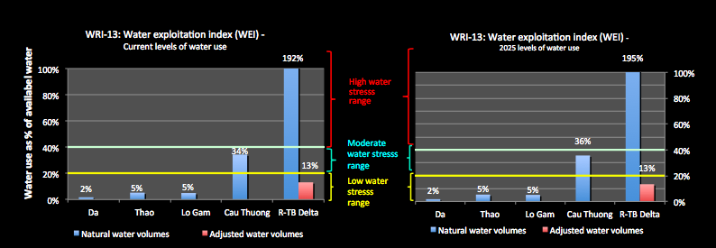
The chart shows that, based on the water resources generated within the sub-basins, current levels of water use are within the low water stress zone, except for the Cau-Thuong and the Delta. However, when the water available in the Delta is adjusted to account for the through-flows from the upper sub-basins (the red column in the chart), the current level of exploitation of the Delta is also in the low stress zone. The Cau-Thuong sub-basin already has a moderate water exploitation stress level based on annual water use and water availability. The figures do not change significantly when projected 2025 water exploitation levels are used.
WRI-14 is the dry season water exploitation Index. This is the proportion of the natural dry season water volume in the sub-basin that is exploited and used under: (a) current dry season levels of water demand/use; (b) projected 2015 dry season levels of water demand/use. The indicator relates exploitation and use to the available natural water and can identify if abstractions rates are sustainable. A high % leads to pressure on the water resources. Water exploitation and use in the dry season compared to the water availability in the dry season can help identify if dry season exploitation and use rates are sustainable.
The results for the RTBRB are presented in the following chart:
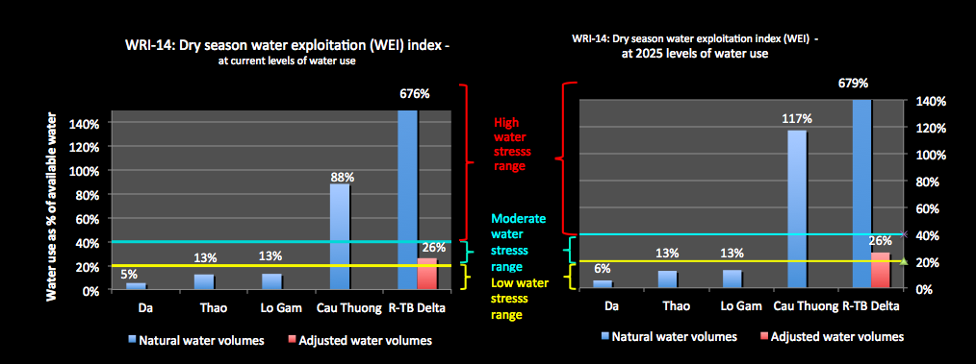
The chart shows that the Da, Thao and the Lo-Gam sub-basins are at the low stress level. When the Delta is adjusted to account for the dry season inflows from the upper sub-basins (the red column in the figure), the current level of exploitation of the Delta is in the moderate stress zone. This is much the same result at the projected 2025 dry season water exploitation levels. However, the figures for the Cau-Thuong are of major concern. At current levels of dry season water exploitation and available water, the sub-basin is in the high stress range (with 88% of the available water being used to meet the demands), and this is further accentuated at the projected 2025 level of water exploitation. At that time, over 100% of the available water would be required to support water exploitation; an impossible figure producing great stress on the river system and the communities that depend on the water sources of the sub-basin.
WRI-15 is the water exploitation per capita Indicator. This is the (a) current total water use/demands in the sub-basin divided by current population (VN only); and (b) the projected 2025 total water use/demands in the sub-basin divided by projected population at 2025 (VN only). A high figure means that water use in this basin is for relatively higher water using activities, or it could mean inefficient water use. The indicator indicates the average total water use per person in the basin (cu m per capita), at present and projected at 2025. The results for the RTBRB are presented in the following chart:
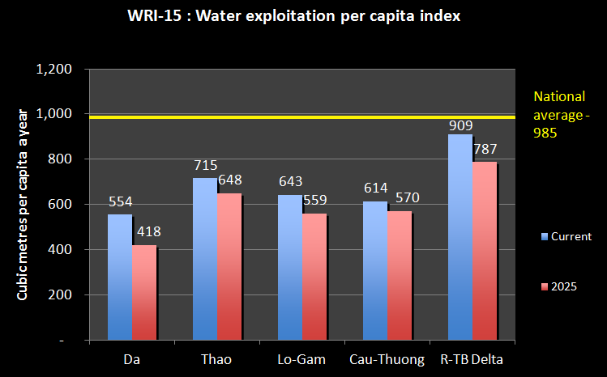
The chart shows that the water exploitation per capita in all of the sub-basins is less than the national average, and also significantly less than the water availability per capita previously discussed. However, for the Cau-Thuong, the available water is only 523 m³ per capita, indicating that the available water is currently being fully used (see WRI-11 and WRI-12).
WRI-16 is the Sector Water use Indicator. This shows the proportion of total water use by the major sectors - irrigations, agriculture, industry, urban, and aquaculture.
The indicator identifies the major uses of water in the basin and shows the water use in each sub-basin by each main water-using sub-sector - irrigation, agriculture, industry, urban, aquaculture. Accurate data and information on water use in Viet Nam is generally not available, except for the urban sub-sector where most use is measured. Figures therefore must be based on the best available estimates and identifies the major uses of water in the sub-basin.
The results for the RTBRB are presented in the following chart:
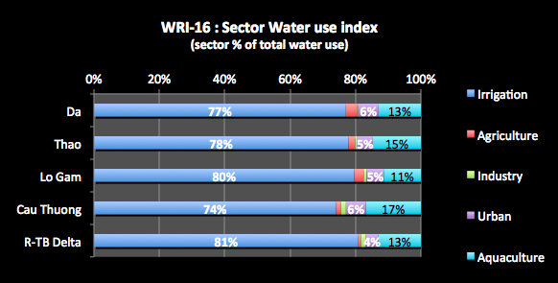
Nationally, irrigation accounts for over 80% of total water use; aquaculture 11%; industry 5%; and cities, towns & villages 3%. In the RTBRB irrigation water use is greatest in the Delta sub-basin, at 81% of total estimated water use. Irrigation use is at or just less that 80% in the Da, Thao and the Lo-Gam sub-basins, but is only 74% for the Cau-Thuong. This helps explain why this sub-basin has a relatively low water use per capita. Water use for aquaculture is very high in the Cau-Thuong at 17%. Urban and industrial water use is small in comparison to irrigation and aquaculture water use.

Data sources and comments
Discharge data sources are those provided for earlier indicators, and the comments provided in relation to these also apply here. The following should also be noted with respect to the data used:
- Note that the water demand is different from water use, especially in agriculture. However, to have real data and information of water use requires a good water resources monitoring system which is not currently ready in the Red-Thai Binh river basin. For this report, water demand considered as water use. Water use is not generally directly measured in Viet Nam. Therefore the data that you will generate and use will mostly be estimates of water demands.
- Water demands data may be found in a range of Ministry or project reports. Two such reports are, to be used preferentially in the following order:
- MoNRE (2005), report to the NWRC on 9 major river basins, using 2003 data,
- JICA (2001), Study on Nationwide Water Resource Development and Management), using data from earlier years;
While these figures may not be completely accurate, they do give a good picture of the approximate demands in a river basin compared to average annual discharge in the basin.
- Dry season discharge figures were adjusted for inter sub-basin contributions and inter-basin transfers via water works infrastructure, and any active water storage volumes were added in.
- The water exploitation indicators are defined as the average annual total exploitation of freshwater divided by the mean annual surface water discharge (inter sub-basin contributions and inter-basin transfers via water works infrastructure), and the average dry season exploitation of freshwater divided by the average dry season surface water discharge (adjusted for inter sub-basin contributions and inter-basin transfers via water works infrastructure, and active storage). According to the literature, the warning threshold of water stress can be 20% of the flow being extracted, which distinguishes a non-stressed region from a stressed region (Raskin et al., 1997, Lane et al., 2000). Severe water stress can occur where the indicator exceeds 40%, indicating strong competition for water but which does not necessarily trigger frequent water crises. Some experts argue that 40 % is too low a threshold, and that water resources can be used much more intensely, up to a 60 % threshold. Others argue that freshwater ecosystems cannot remain healthy if the waters in a river basin are abstracted as intensely as indicated by an indicator in excess of 40 % (Alcamo et al., 2000).

3.7 Flood Indicator

Explanation of flood indicators
WRI-17 is the flood mitigation storage Indicator. This is total reservoir storage volume in the sub-basin used for flood mitigation, compared to wet season water volume in the sub-basin.
The indicator shows the relative size of flood mitigation reservoirs in the sub-basin, compared to wet weather water volume in the sub-basin. A higher ratio means a greater proportion of wet season basin flows could potentially be caught in a reservoir.
The results for the RTBRB are presented in the following chart:
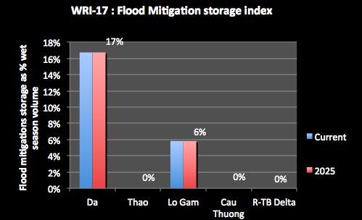

The chart shows that the flood mitigation capacity of the reservoirs in the Da sub-basin is 17% of the wet weather water volume. The figure is 6% for the Lo-Gam. This means that a significant proportion of wet season basin flows generated in the upper rivers can potentially be caught in a reservoir, suggesting that the reservoirs can have significant impacts on the flood in the Delta sub-basin.

3.8 Climate change Indicators

Explanation of climate change indicators
The climate change indicator used depends very much on the data available at the sub-basin scale. In this case there were few options and changes in temperature were used.
WRI-18 is the climate change temperature indicator for Sub-Basin. This is the ratio of the average summer temperature over the recent history compared to that projected for the sub-basin under climate change. It shows the temperature increase and the relative increase in the average summer temperatures in the sub-basins. A high % means a significant increase in summer heat, causing increased evaporation: reducing runoff and increasing the demands for water within the sub-basin.
The results for the RTBRB are presented in the following chart:
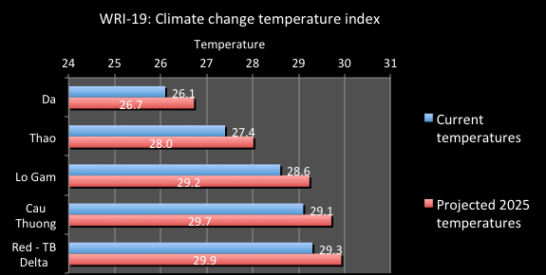
This shows that the Lo-Gam, Cau-Thuong and Delta sub-basins are naturally warmer that the other sub-basins. However, the Da sub-basin is projected to have a slightly larger increase in temperature compared to current levels – an increase of 2.4%. The other sub-basins are projected to experience slightly more than a 2% change in temperature.

4. Groundwater Indicators
For the sustainable management of groundwater in the Basin, ‘groundwater potential’ is assessed against the recharge to the Basin’s aquifers. It does not include any groundwater storage component which, if extracted, would result in the unsustainable mining of groundwater over time. In the indicators the term “groundwater exploitation capacity” is used. This is the volume of groundwater that may be extracted on a sustainable basis, and it will be a quantity less than the assessed annual recharge to the aquifer.
Groundwater aquifers do not always physically align themselves with basin groups, and although the geological structures within which groundwater occurs are generally known, a detailed delineation of aquifers has not been undertaken. If this is a critical issue then one of the recommendations of the National Plan would be to undertake this. Meanwhile, for the preparation of the Status Report, professional judgement will be required to prepare and analyse the data for the groundwater indicators for the aquifers of the basin groups.

4.1 Explanation of groundwater indicators
GWI-1 is the Groundwater area Indicator. This is the proportion of aquifer type areas in the Basin overall, and area of aquifer type in each sub-basin. A low % means that the basin group contains little usable groundwater.
It indicates the proportion of the basin’s total area provided by each aquifer type and also shows the area of each aquifer type in the sub-basins. A high % indicates that a substantial part of the Basin's groundwater area is provided by an aquifer type or a sub-basin. Depending on the aquifer type this could indicate the groundwater potential. For example a high % of fractured rocks may indicate that although there will be groundwater available the potential bore yields may be small.
The results for the RTBRB are presented in the following chart:
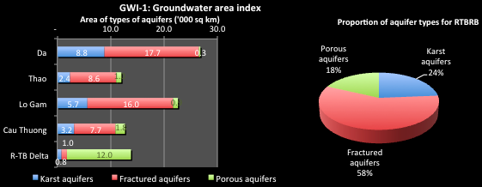
The total groundwater area in the Basin is estimated at 87,880 km². The chart shows that fractured rock aquifers are the most common aquifer type, comprising over 50,000 km² or 58% of the total aquifer area. This aquifer type dominates the aquifer areas in the upper sub-basins. However, the Delta is dominated by porous aquifers formed through the deposition of sands and gravels over the centuries. The alluvial aquifers are generally more productive that fractured rock aquifers suggesting good groundwater potential in the Delta sub-basin.
GWI-2 is the Groundwater Recharge Indicator. This is the proportion of the Basin groundwater recharge that is provided by each sub-basin; and the recharge volumes in the aquifer types in the sub-basins. A high % indicates that a substantial proportion of the Basin's groundwater potential is provided by a sub-basin. A low % means that the sub-basin most likely contains little usable groundwater.
The results for the RTBRB are presented in the following chart:
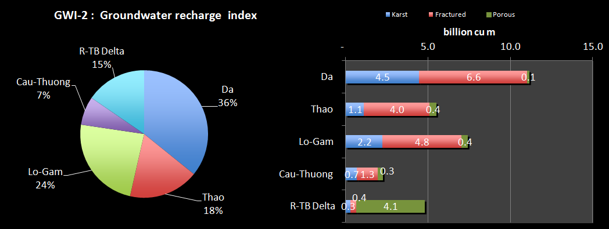
The natural recharge to the aquifers in the RTBRB is estimated at over 31 billion m³ a year. Most of this recharge occurs in the Da sub-basin (36%), with only 7% in the Cau-Thuong sub-basin. For the Delta, 86% of the recharge (nearly 5 billion m³ a year) occurs to the porous aquifers. In the other sub-basins around 60% of the recharge is to the fractured rock aquifers, which receives 55% of the total recharge (karst receives 28% and porous aquifers 17%). Most of the recharge to the karst aquifers is in the Da Sub-basin (4.5 billion m³ a year). Notable, the Cau-Thuong sub-basin, which is highly stressed for surface water, does not receive much groundwater recharge – less that 2.3 billion m³ a year.
GWI-3 is the groundwater recharge potential Indicator. This is the recharge of the aquifer types per land area. It indicates the types of aquifer that provided the most recharge and their location in the sub-basins. It can show the more important recharge areas that may need to be protected. The results for the RTBRB are presented in the following chart:
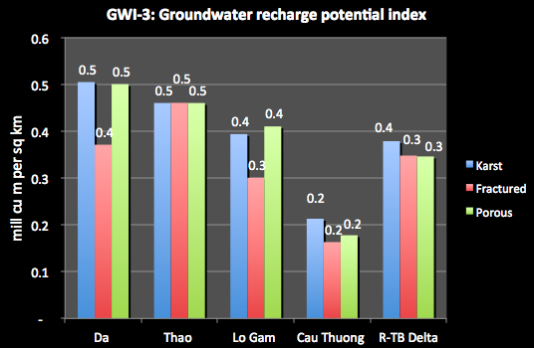
The chart shows that the aquifer areas and the recharge to them can be combined to determine which locations produce the most recharge to groundwater. The chart indicates high recharge potential for the aquifers in the Da, Thao and Lo-Gam sub-basins, with lesser potential in the Delta. The Cau-Thuong sub-basin has a relatively low recharge potential for all aquifer types.
GWI-4 is the groundwater exploitation Indicator. This is the proportion of the basin groundwater exploitation capacity in the sub-basins and the exploitation capacity in the aquifer types in the sub-basins.
It indicates the proportion of the Basin's total exploitation capacity that is provided by the sub-basin; and also shows the exploitation capacity of the aquifer types in the sub-basins
The results for the RTBRB are presented in the following chart:
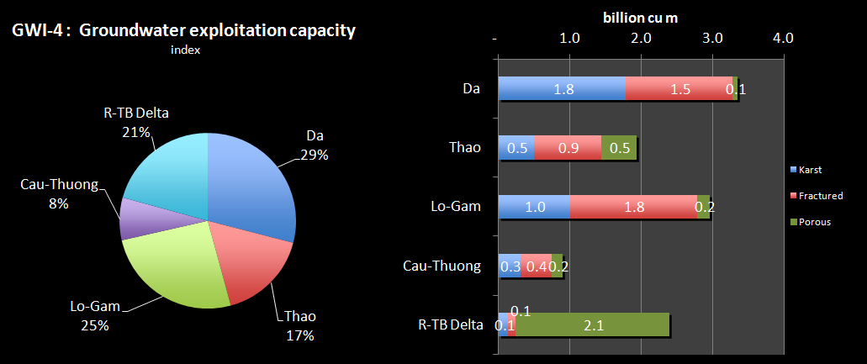
The chart shows that the Da sub-basin has the highest exploitation capacity at 29%. The Lo-Gam sub-basin has the second highest level of exploitation capacity, while the Cau-Thuong has only a very small exploitation capacity (8%).
GWI-5 is the groundwater sustainability Indicator. This is the ratio of the exploitation capacity of the aquifer to the natural discharge. For a sustainable aquifer system, the assessed exploitation capacity should be less that the natural recharge, recognising that some of the recharge is required to sustain aquifer processes and some surface environment such as wetlands, and provide low flows to some rivers in dry times. In some countries a general level of 70% is taken as the default ratio. The proportion must be determined by groundwater specialists taking into account the characteristics of the aquifer (permeability, transmissivity, recharges mechanisms, groundwater flow and surface connections, etc.).
The indicator shows the sustainability of the exploitation capacity of the aquifer. A % greater than 100% means that the groundwater of the aquifer is being mined - water is being extracted at greater than the recharge rate, which means that water is being taken from the aquifer storage volume, which many not be replaced. The only time when greater than 100% is sustainable is when there is induced recharge to the aquifer – when the extractions induce recharge that would not normally occur as the aquifer is full or near full.
The results for the RTBRB are presented in the following chart:
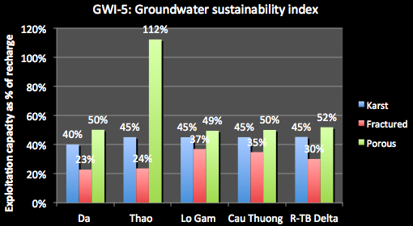
The chart shows that shows the results, with most sub-basin and aquifer types at or below 50%, which is suggesting that most groundwater use is sustainable. The clear exception is for the Thao sub-basin, which is at 112%. This is because of induced recharge in that river system. There are strong connections between the river and the aquifer and the significant withdrawals actually induce more recharge than would occur naturally. It must also be remembered that his indicator is calculated as aquifer averages. There will be some areas of intense water exploitation where the current levels of extraction are not sustainable and are resulting in lowering water levels.
GWI-6 is the groundwater availability Indicator. It is the exploitation capacity of the sub-basin divided by divided by: (a) current population (VN only); (b) projected population at 2025 (VN only). This indicator relates the sustainable groundwater to the population (current and at 2025) (m³ per capita). It should be considered in conjunction with surface water availability, particularly in the dry season. While the two are not additive as groundwater is well spread throughout the sub-basins and will depend on the construction of a great many individual extraction points, together they do indicate the overall water availability per capita. The results for the RTBRB are presented in the following chart:
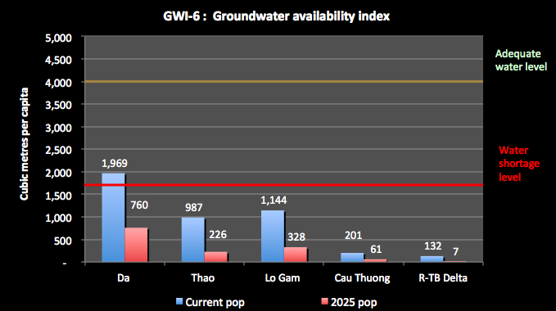
The indicator shows the ability of the water resources to support the population now and into the future. 4,000m³/year/ person indicate adequate water supply. More than 1,700m³/capita/year is defined as the threshold above which water shortage occurs irregularly or locally. Below 1,700m³/ capita/ year water stress appears regularly. Below 1,000m³/capita/year water scarcity is a limitation to economic development and human health and well-being.
The chart shows that Da sub-basin has by far the greatest groundwater availability per capita, with the Delta and Cau-Thuong having very little groundwater availability per capita. Groundwater could not on its own support the populations in the sub-basins, and this will be even less so in the future. However, groundwater is a very important resource in many specific locations.
GWI-7 is the overall groundwater use indicator. This is the proportion of the total Basin groundwater use provided by each of the sub-basins.
It indicates the proportion of the Basin’s total groundwater use that is supported by the sub-basin. A high % indicates that a substantial proportion of the Basin's groundwater use occurs in a sub-basin. A low % means that there is relatively little groundwater use in the sub-basin. The results for the RTBRB are presented in the following chart:
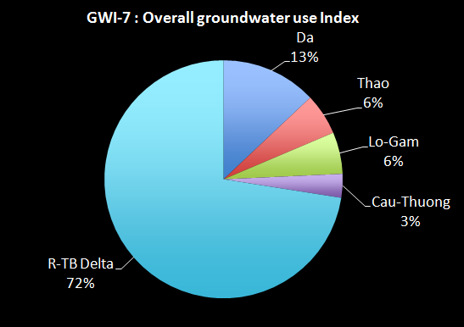
The current groundwater use is estimated at 1.11 billion m³ a year. The chart shows that nearly 72% of the use is in the Delta sub-basin, mostly from the alluvial aquifers, showing the importance of groundwater in the area. Although, it has substantial groundwater resources, the Da sub-basin has relatively small use at only 13% of the overall total. The Cau-Thuong has the smallest proportion of use at only 3%.
GWI-8 is the groundwater use per sector indicator. This is the proportion of the sub-basin groundwater use by the sectors (towns, industrial zones, rural water supply).
It indicates the proportion of the sub-basin’s groundwater use by the sectors – towns, industrial zones, rural water supply, other / unknown. A high % for any of the sectors indicates the dependence of that sector on groundwater. A low % means that the sector has alternative supplies of groundwater. A high percentage for "other/unknown" means that water use monitoring is inadequate, and is generally poorly understood.
The results for the RTBRB are presented in the following chart:
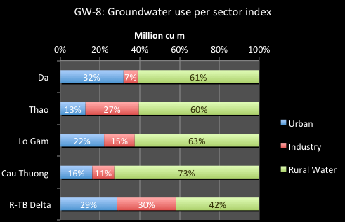
Generally over half of the water use is for rural water supply (602 million m³ a year). The remaining use is shared between urban use and industry. In the Delta sub-basin, there is also substantial use made of groundwater for urban water supply (for Hanoi) and for industrial development.
GWI-9 is the groundwater use per aquifer type indicator. This is the groundwater use by the sectors (towns, industrial zones, rural water supply) and by aquifer type.
The indicator shows the sub-basin's groundwater use by the sectors - towns, industrial zones, rural water supply, other/unknown - and by aquifer type. A high use for any of the sectors indicates strong dependence of that sector on groundwater from a particular aquifer type. This may focus the groundwater management effort onto specific aquifer types in localities to protect water supply.
The results for the RTBRB are presented in the following chart:
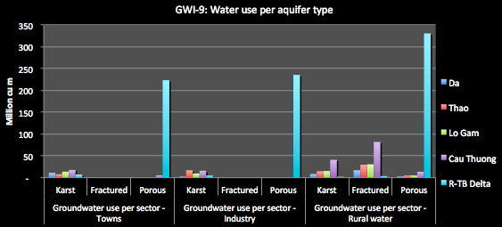
The chart clearly demonstrates: the significant groundwater use in the Delta compared to the other sub-basins; the dominance of rural water supply as the water use purpose, from all aquifer types and locations; the importance of the karst aquifers in the upper sub-basins; and the use of fractured rocks in the Delta but not in the other sub-basins. In the future, groundwater use is expected to increase in all sub-basins, but more particularly in the Delta – as the scarcity of surface water becomes more evident.

GWI-10 is the future groundwater use indicator. This is the 2025 proportion of the sub-basin groundwater use by the sectors (towns, industrial zones, rural water supply).
The results for the RTBRB are presented in the following chart:
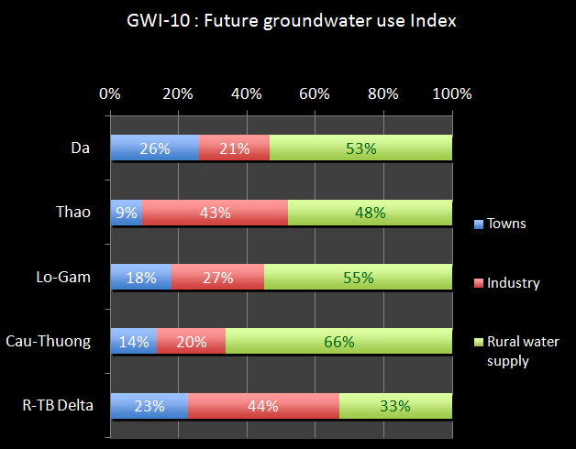
Compared to GWI-8, this shows significant increase in groundwater dependence from industrial development in all sub-basins. As a proportion of use, rural water supply will decrease although the volumes used will increase; this is similar for town water use.
GWI-11 is the groundwater use and exploitation capacity indicator. This is the ratio of groundwater use compared to the groundwater exploitation capacity, under current and 2025 conditions. The indicator shows the amount of the assessed exploitation capacity that is required to meet current and projected 2025 water uses.
The results for the RTBRB are presented in the following chart:
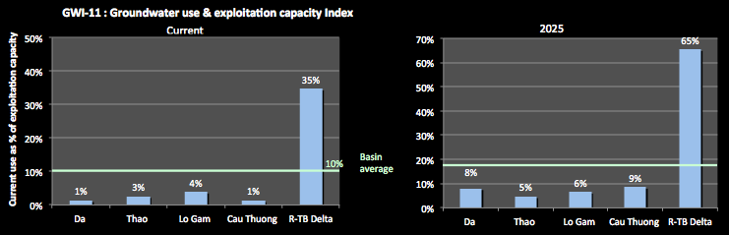
In the future, groundwater use is expected to increase in all sub-basins, but more particularly in the Delta. This increased use in the Delta will bring the use to around 65% of the exploitation capacity. Given that the recharge is spread out over the areas of the aquifer, such high levels of use is likely to mean very intense use at the local level and drawdown of the water levels unless there is very careful management of extractions. For all other sub-basins, the increase in use does not threaten the resource overall (although this may vary at locations of intense extraction).
GWI-12 is the area affected by drawdown indicator. This is the ratio of the area of the aquifer suffering groundwater level drawdown to the total aquifer area.
It indicates the extent of the aquifer suffering from dropping water levels due to local over-exploitation. This will allow priorities for actions to be established. A high number indicates a major lowering of water levels without recovery through natural process. This means that the aquifer is being mined in some localities, and aquifer storage is being extracted. Extraction will progressively cost more (higher pumping cost), the likelihood of drawing in poor quality water increases, and land use impacts can result, such as compaction and settlement.
The results for the RTBRB are presented in the following chart:
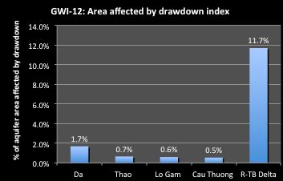
The chart shows that all sub-basins are affected by lowering water levels to some extent. Although for most sub-basins this issue appears small, the analysis shows that there are areas in all sub-basins where lowering of water levels without recovery through natural process is already occurring. This means that the aquifer is being mined in some localities, and aquifer storage is being extracted. Extraction will progressively cost more (higher pumping cost), the likelihood of drawing in poor quality water increases, and land use impacts can result, such as compaction and settlement. This is worst in the Delta where lowering water tables around Hanoi now extend to an area of over 1,600km². Studies have shown a water level depletion of 8 - 14m in two measured areas, which is ongoing. This has resulted in a threat to the sustainable supply of water for Hanoi and land subsidence on the southern bank of the Red River. Of the 91 monitoring bores, 17 have shown water level lowering of up to 10% and a further 8 have shown a water level lowering of up to 40%.
GWI-13 is the groundwater quality indicator. This is the % of the aquifer areas that are subject to saline water and arsenic contamination. The indicator shows the significance of saline water and arsenic contamination to the aquifer. A high number indicates that major parts of the aquifer are not suitable for exploitation and use. As well, careful management of these areas is required to ensure that contaminated water does not move into good quality aquifer.
The results for the RTBRB are presented in the following chart:

The chart shows that groundwater in the Delta sub-basin (Ha Nam and Nam Dinh provinces and parts of Hanoi) are seriously polluted with arsenic, covering an area of over 2,500 km². In Hanoi, groundwater polluted with arsenic has been found since 1996. Of some 165,000 samples tested, 31,048 have had an arsenic concentration greater than 0.05 mg/l, the Vietnamese standard, and a further 26,722 recorded levels of between the standard and 0.01 mg/l, the WHO standard. Samples are hundreds of times greater than the WHO standard. All other sub-basins have some record of arsenic contamination above the standard – 4 samples in the Da, 2 in the Thoa, 7 in the Lo-Gam, and 30 in the Cau-Thuong.

Data sources and comments
- Groundwater potential (recharge) will generally need to be assessed for the main aquifers – little existing information will be available on this. Information for this may be sources from various research reports such as from Research project 44-04-01-01, Research project of Mining-Geology University and Hydrology data, from program advance Science-Technology, State level, and some project level groundwater assessments. Calculations should be based on:
  - The volume of groundwater discharge to rivers in mountainous areas, where the river discharge is the average of the month with the minimum discharge in each year of record, or
  - The annual change in water level was estimated from field studies or data where available, or
  - Recharge of rainfall to groundwater in delta areas, estimated as a proportion of average annual rainfall which infiltrates into the uppermost freshwater aquifer, using infiltration rates range from 5-10% of rainfall, depending on the aquifer type
- Currently, there is no national inventory on the use of groundwater. Data was sourced from reports available at the MoNRE Department of Water Resources Management, and DONREs. Assessments may also be derived from:
  - Statistical data on upland cropping in mountainous areas, and winter – spring rice plantings in other areas, and the volume of irrigation water use per ha in each area.
  - Estimates of use by large scale Water supply companies based on the results of investigation data of single wells and bore fields, and from company records where these exist. This is likely to be an underestimation of use.
  - Estimates of groundwater use per capita of rural populations, and estimates of the number of small bores and dug wells.

5. Social Development Indicators
The social development indicators seek to show the relationship between the social conditions in Viet Nam and in the river basins, and the provision of basic water services to people. They also show the impacts of extreme water related disasters on communities.

5.1 Population Indicators

Explanation of Population Indicators
SDI-1 is the Basin population indicator. This shows the sub-basin population as a percentage of the total basin population.
This indicates how many people live in and depend on this sub-basin in a Basin context. The higher the percentage, the greater the significance to the Basin overall in terms of putting pressure on the water and related natural resources, and in the potential demands for water services.
The results for the RTBRB are presented in the following chart:
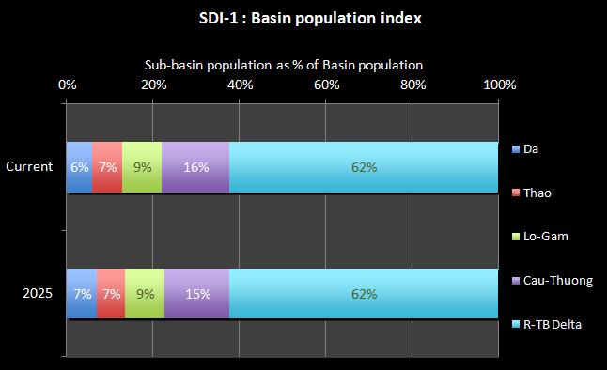
The total population of the RTBRB is 28.4 million people (at 2010). The chart shows that 62% of the population currently lives in the Delta sub-basin, which will remain stable until 2025. The Cau-Thuong currently has 16% of the people and this is projected to decrease to 15% by 2025. The three western sub-basins host a relatively small part of the population (less than 10% each) and this is not expected to increase much in the future.
SDI-2 is the population growth indicator. This is the percentage of population growth experienced in the basin. It indicates the potential growth of the population and the changes in impacts of people on water sources over time. A high percentage suggests a faster growing population and therefore greater potential impacts on the basin group.
The indicator shows the changes in impacts of people on water sources. A high percentage growth suggests a faster growing population and therefore greater potential impacts on the water resources of the basin. The results for the RTBRB are presented in the following chart:
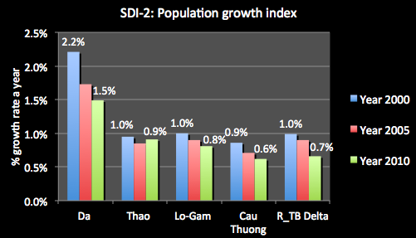
The chart shows the changes in the population growth rates of the sub-basins from 2002 to 2010. These have declined in all sub-basins. The significance of this change can be appreciated when we think of population growth rate in terms of its doubling time. A continuous growth rate of 2% will double a population in 35 years, but a rate of 1.4% would require 50 years. At present, the highest growth rate is in the Da sub-basin, which is more than twice the rate for the Delta.
SDI-3 is the population density indicator. This is the basin population divided by the basin area.
It indicates the pressure on the river basin from the density of people (the number of people per sq. km). A high percentage suggests greater potential impacts on the basin. The national average is about 250 people per sq. km.
The results for the RTBRB are presented in the following chart:
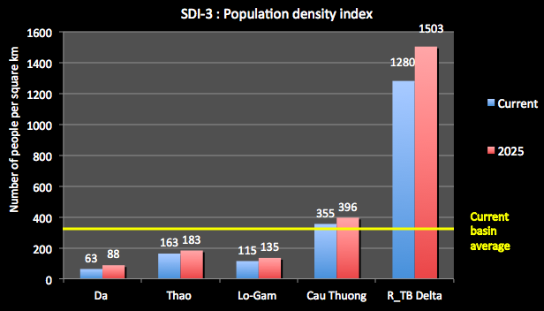
Population density is one of the key pressure indicators on water resources and their associated environments. The chart shows that population density varies across the sub-basins, with the Delta over 3.5 times the national average, suggesting great pressure on the water resources of the area. In Hanoi City the density is even greater at 1,962 people per km². This compares to 3,530 people per km² for HCMC, around 14,450 for Jakarta, 7,400 for Beijing, 6,415 for Hong Kong and 4,478 for Bangkok. As Hanoi’s population density is below the levels of some regional cities, there is still time to create a more sustainable city for the ongoing development of Hanoi. However, some immediate actions will be required - already in Hanoi some river sections are considered as “dead” rivers, unable to support any life, and this is expected to worsen as populations increase
SDI-4 is the rural-urban indicator. This is the ratio of the population in rural and urban areas.
It indicates the proportion of the population that live in urban and rural areas and therefore, the level of water services they may require. A higher proportion of rural people may suggest that this basin may need special consideration for pro poor development.
The results for the RTBRB are presented in the following chart:
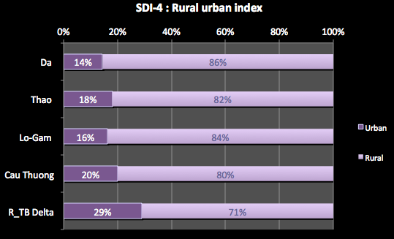
Currently, rural populations clearly dominate urban populations in the RTBRB – at over 80% in all sub-basins except the Delta. However, there is a strong trend to urbanisation associated with industrial development around the urban centres. The National urban population is projected to be nearly 60% of the total population in 2049 (it is currently 32%).

Data sources and comments
The Basin population figures was sourced from GSO website: www.gso.gov.vn. Sub-basin populations were derived from provincial and district populations according to apportionment of provinces and districts to sub-basins as required. Projections of populations into the future can also be obtained from the GSO.
The rural-urban population distributions assume that urban areas are defined as special urban centres, and class I to V urban centres, as defined by Decree 42/2009/NĐ-CP (signed 7th May 2009). They also assume that settlements (communes and villages) of less than 4,000 people are included in the rural population. However, the migration from rural to urban area is not taken into account and there limitation on these data.

5.2 Poverty and employment indicators

Explanation of poverty, ethnicity and employment indicators
For the poor, which often includes people of ethnic origins and the unemployed, water and water services are amongst the most critical factors for their future social and economic improvement. For example, water and sanitation availability, as per Millennium Development Goal (MDG) 7, influences health, gender issues, and the economy, making them central to achieving several of the MDGs. A recent study of data from 193 countries assessed the influence of water and sanitation against indicators associated with MDGs 1 to 6 as follows:

Table 1. Influence of water and sanitation on MDGs
Millennium Development Goal | Influence of water and sanitation on MDG
Millennium Development Goal | Water supply | Sanitation
Poverty and hunger (MDG 1) | ☑ | ☒
Primary education (MDG 2) | ☒ | ☒
Gender equality (MDG 3) | ☑ | ☒
Child mortality (MDG 4) | ☑ | ☑
Maternal health (MDG 5) | ☑ | ☑
Diseases (MDG 6) | ☑ | ☒
☑statistically significant relationships between the provision of water or sanitation and the MDG.
☒not statistically significant relationships between the provision of water or sanitation and the MDG.
The analysis found statistically significant relationships between access to an improved water source and indicators for Goals 1, 3, 4, 5 and 6; and access to improved sanitation for Goals 4 & 5. Clearly, a good understanding of poverty, ethnicity and unemployment is an important part of setting out tasks for river basin planning.
SDI-5 is the poverty number indicator. This shows the number of people the number of people in the sub-basin community assessed as living in poverty, and the percentage of households.
This indicator shows the number of people and households in poverty in the sub-basin, and thus indicates the number of people vitally interested in water availability, quality and quantity.
The results for the RTBRB are presented in the following chart:
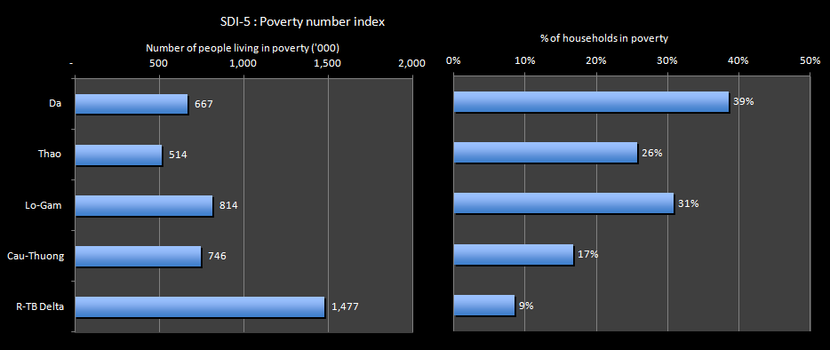
The chart shows that while the Delta sub-basin has more people living in poverty (nearly 1.5 million), the Da has more persistent poverty with nearly 40% of households affected. In the Da sub-basin, the poverty-affected people are likely to be scattered and living in remote areas, making it difficult to assist them. The Lo-Gam also faces a difficult poverty situation with over 800,000 people and nearly a third of households affected by poverty.
SDI-6 is the ethnic minority indicator. This is the percentage of ethnic minority people in the total population. A high percentage suggests that the basin may need special consideration for provision of water services.
This can broadly indicate a need for provision of water services and also the degree of difficulty in providing services.
The results for the RTBRB are presented in the following chart:
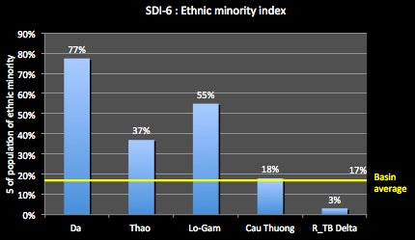
The chart shows that 77% of the population of the Da sub-basin is of an ethnic minority group, and 55% in the Lo-Gam. The RTBRB average is 17% and the Delta sub-basin is well below this at 3%.
SDI-7 is the employment index. This is the percentage of people employed in the main sectors - agricultural, industry, and services.
It indicates the ratio of people working in the 3 sectors, which can be related to water used and GDP generated. Together these indicators will allow deductions to be made on efficiency and effectiveness of water use compared to the inputs. The results for the RTBRB are presented in the following chart:
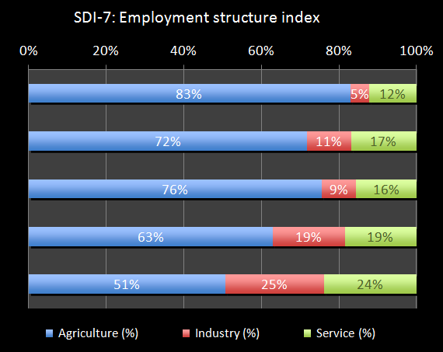
The chart shows the employment structure of the sub-basins. The Da sub-basin is quite striking in that, of the people employed, 83% are employed in agriculture despite the fact that agriculture only contributes 35% to GDP. In many respects, the economic structure of this sub-basin is more like the Viet Nam structure of 1990 than that of today. Agricultural employment also dominates the other sub-basins. Employment in the agriculture sector in the Delta sub-basin remains at 51% with agriculture providing only 15% of GDP.
SDI-8 is the unemployment indicator. This is the percentage of people unemployed in the basin. It indicates the ratio of people without a job and therefore who live in difficult circumstances. A high percentage suggests that this basin group may need special consideration for pro poor developments. The results for the RTBRB are presented in the following chart:
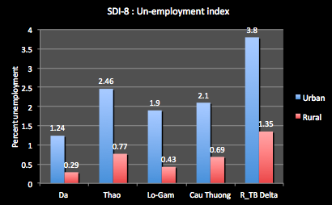
The chart shows that in the RTBRB, unemployment ranges widely between the sub-basins and between urban and rural areas. The highest rate is for the urban areas of the Delta sub-basins at 3.8%. Unemployment is generally greater in urban areas. However, even in the Da sub-basins, overall unemployment is a small rate.

Data sources and comments
For the poverty indicators, provincial scale data on the total number of households and the number of households assessed as living in poverty were obtained from the provincial statistical yearbooks, GSO, and from the Ministry of Labour, Invalids and Social Affairs (MoLISA). Data was adjusted to account for provinces in more than one sub-basin. In making this adjustment, you can assess the number of poor people living in each sub-basin by assuming an average of five people per household.

5.3 Water related services indicators

Explanation of water related services indicators
SDI-9 is the urban clean water indicator. This shows the proportion of people with access to clean water in urban areas under direct control of the central or provincial governments, and in district level urban areas, expressed as a percentage. A high percentage shows good access to essential services. A low percentage means that access to clean water is not generally available so the poorer people have to obtain access to raw or untreated water, or buy clean water, which is expensive.
It is sometimes found that provision of services at District level is far less effective that at the larger cities and towns under Provincial control, so this aspect needs to be examined.
The results for the RTBRB are presented in the following chart:
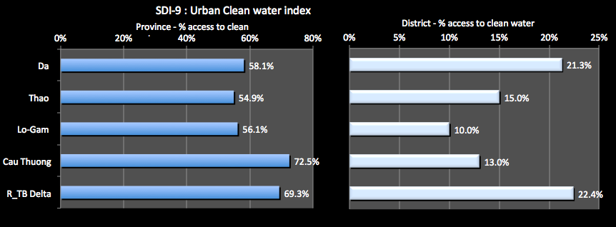
The chart shows that a high percentage of people in Provincially controlled urban areas in all of the sub-basins have access to clean water in the home - from 55% up to a high of 72% in the Cau-Thuong sub-basin. However for the District controlled urban areas, the coverage is substantially less, and as low as 10% in the Lo-Gam. This is serious inequity in the provision of basic services.
SDI-10 is the rural hygienic water indicator. This shows the proportion of people in rural areas with access to clean water in their home or at a public facility. It indicates the access people have to clean water in rural areas and the nature of that access. A high percentage shows good access to essential services. A low percentage means that access to hygienic water is not generally available so the poorer people have to obtain access to raw water in rivers, use untreated water, or buy clean water, which is expensive. Here, hygienic water is a judgment based on 5 informal parameters used by MARD. The general condition is that water is safe for drinking after boiling; however, this has not been put into a legal document.
Ideally, this indicator would be based on MoH standards for Domestic Water which would allow this indicator to be compared directly with SDI-9. The MoH has issued QCVN 02:2009/BYT “National technical regulation on domestic water quality” which specifies 14 parameters to be measured. Unfortunately, that data does not exist for rural water supply in Vietnam. Moreover, the current government priority is to ensure delivery of enough water, rather than clean water. If, the government priority changes to delivery of rural water supply at MoH Domestic Water standards and data are collected to monitor this coverage, then this indicator should be modified from “hygienic” water to “clean” water. A current rough estimate is that rural water supply at MoH standards is 40-50% of delivery at MARD’s rating.
The results for the RTBRB are presented in the following chart:
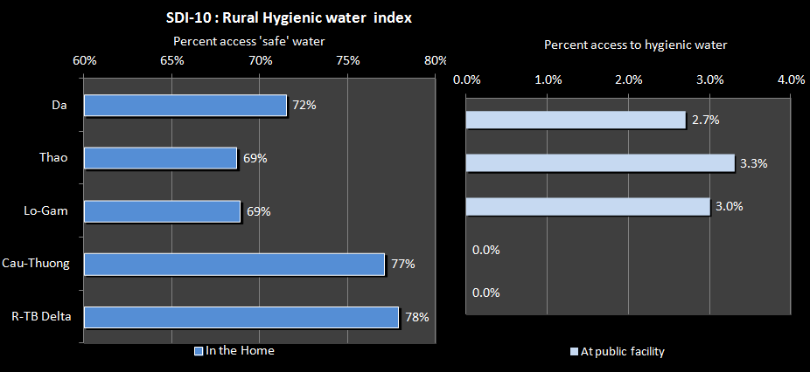
This shows that nearly three-quarters of the rural people in the RTBRB have access to ‘hygienic’ water in the home. Such high numbers are the result of the concentrated National Target Program for rural water supply and sanitation led by MARD. The third phase of this program is now underway. The Thao and Lo-Gam have the lowest percentages. Few people depend of a public facility for their water supply.
However, it is likely that only about 25% to 40% of rural people in the sub-basins are receiving water supply that meets the MoH Standard, resulting in a major gap between rural and urban people.
SDI-11 is the urban sanitation indicator. This is the proportion of people with access to sanitation in urban areas.
It indicates the access people have to sanitation services in urban areas in the sub-basin, at different levels. A high percentage shows good access to essential services. Note that these figures do not mean that the sewerage is taken away or treated – see Environmental indicator EVI-9. A low percentage means that people have to use makeshift facilities, often directly into the natural environment.
The results for the RTBRB are presented in the following chart:
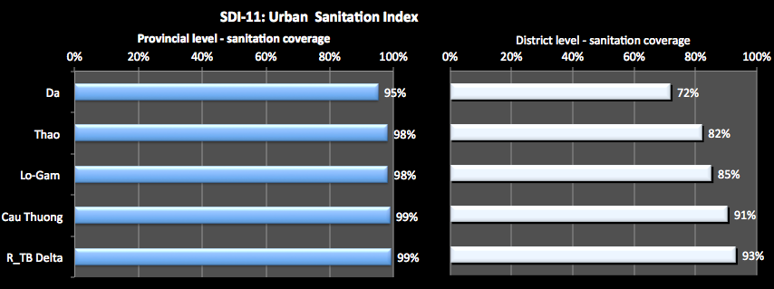
The chart shows that the vast majority of the population that has access to sanitation in the home. In the Delta sub-basin the figure is almost 100% (where the total urban population is over 5.1 million people), and is at a high 95% in the Da (where the urban population is nearly 250,000 people). However, while the figures for people having access to a flush toilet in urban areas under the control of the central or provincial governments are high, at the district level, only around 70% to 90% of households have access to a sanitary latrine. While this appears to be a good result, and sanitation in the major cities in Viet Nam is said to be available to 98% of the population, these figure includes access to a “sanitary latrine”: it gives no indication how the human waste thus collected is disposed of. In fact, the majority (75% nationally) of households in provincial towns are not connected to any form of local or central sewerage system, but only to a septic tank. With the exception of Hai Phong, no towns offer a reasonable septic tank de-sludging service.
SDI-12 is the rural sanitation indicator. This is the proportion of people with access to sanitation in rural, both in the home and with public access. It indicates the percentage of people having access to sanitation services (to Health standards) in rural areas, and the nature of that access. A high percentage shows good access to essential services. A low percentage means that people have to use makeshift facilities, often directly into the natural environment. The results for the RTBRB are presented in the following chart:
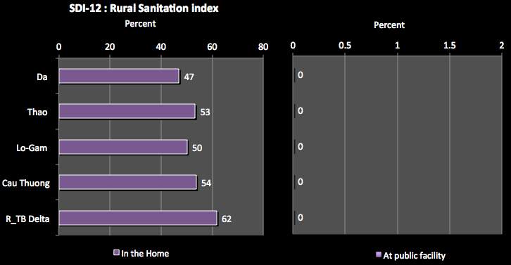
The chart shows that around 50% of the rural population had rural sanitation facilities in the home – note that there so not necessarily meet MOH standards. Mostly about half the homes have sanitation facilities, with a higher rate in the Delta Sub-basin. No data was available for the numbers of people who only had access to public rural sanitation facilities.

Data sources and comments
Data for the urban clean water was calculated by the project based on MoC data and MoH standards. As well, the periodic Viet Nam Household Living Standards Survey was useful.
For the rural clean water indicator, data was based on the MARD hygienic “standards and obtained from MARD. Ideally, the data and information would have come from a “Sector study” on Urban and Rural water supply and sanitation.
For the urban sanitation indicator, a hygienic latrine is defined as being a flush toilet connected to public sewerage system, or a pour flush toilet with septic tank and leach pit.
The rural sanitation indicator, a hygienic latrine is one meeting MoH standards, and is a pour flush toilet with septic tank and leach pit, or a double vault composting latrine. Data was sourced from MARD.

5.4 Water related disaster indicators
SDI-13 is the flood damage indicator. This is the average yearly cost of flood damage in each basin group for a 10 year period, expressed as a percentage of GDP (constant values).
It indicates the damages to the sub-basin community from severe flooding (% of sub-basin GDP). A high percentage indicates that a large proportion of the community are regularly exposed to severe flooding. Typically these will be the poorer people.
The results for the RTBRB are presented in the following chart:
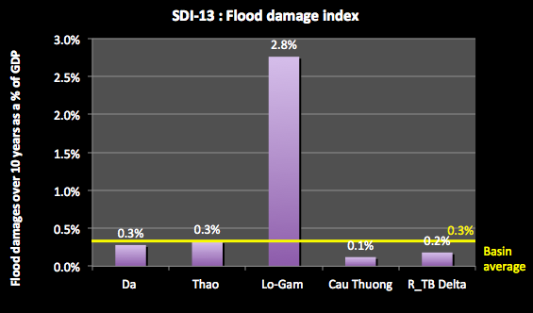
The chart shows that the Lo-Gam sub-basin has been impacted to the extent of 2.8% of GDP, (nearly 10 times the basin average) about equivalent to a quarter of the annual growth rate of the sub-basin economy (10%).; while the other sub-basins have been impacted by 0.3% or less.

Data sources and comments
Data was sourced from the Centre Committee for Flood and Storm Control and Data’s data base on natural hazards. The disaster data includes damage from all natural disasters; however, the majority is from flood events. All data and information can be extracted from the website of the Committee at:
http://www.ccfsc.gov.vn/KW6F2B34/Co-so-du-lieu-thien-tai.aspx

6. Economic Indicators
This section presents the findings of the economic indicators and discusses the major conclusions. The indicators focus on the overall economic performance, economic structure, and productivity from water and its uses.

6.1 GDP Indicators

Explanation of GDP indicators
EDI-1 is the sub-basin GDP indicator. This is the sub-basin GDP divided by the Basin GDP, at current prices. This shows the significance of the current levels of economic activities of the sub-basin to the Basin economy. A high indicator value means that the sub-basin is contributing significantly to the Basin economy compared to other sib-basins.
The chart shows the significance of the economic activities of the sub-basin to the Basin economy. A high indicator value means that the sub-basin is significantly contributing to the basin economy compared to other sub-basins.
The results for the RTBRB are presented in the following chart:
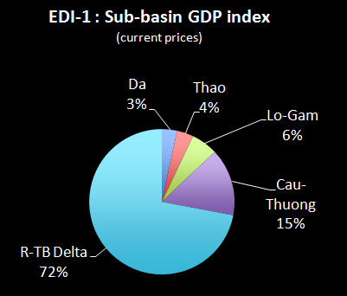
The total GDP for the RTBRB at current prices is 649,366 billion dong (2010) – around a third of the national total. As expected, most of the GDP – 72% - is provided by the Delta sub-basin. The Cau-Thuong provides 15% of GDP and the other sub-basins around 5% each.
EDI-2 is the GDP per capita indicator. This is the sub-basin GDP at current prices divided by sub-basin populations. It shows the current level of per capita income in the basin and sub-basins - the economic outputs of the sub-basin compared to the sub-basin populations. A high indicator value shows that the sub-basin population is contributing significantly to the Basin economy compared to other sub-basins. This is evaluated at constant process to remove the effects of inflation which can distort the figures.
This indicator shows the economic activities of the sub-basin based on the population.
The results for the RTBRB are presented in the following chart:
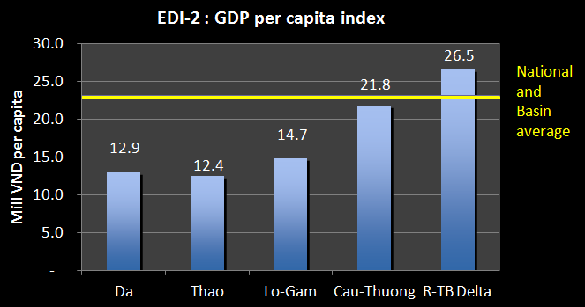
The chart shows that the Delta sub-basin has the highest level, with the Cau-Thuong also high. The other sub-basins are much smaller, meaning a lower standard of living overall.
EDI-3 is the GDP growth indicator. This is the average yearly GDP growth over the last 5 years. It indicates the strength of growth of economic activities of the sub-basin, and is assessed at constant 1994 prices to remove the effects of inflation. A high percentage suggests strong growth, most likely based on the industrial sector. This may have implications for river health.
The results for the RTBRB are presented in the following chart:
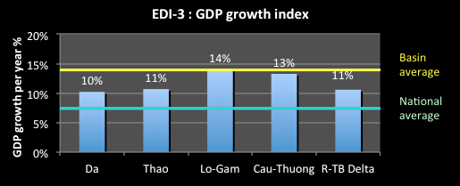
The chart shows that the GDP growth rate for Viet Nam has recently been at around 7% a year, a constant 1994 prices. However, the RTBRB has a growth rate significantly higher than that level. The Lo-Gam and the Cau-Thuong have the highest rate, higher even than the Delta sub-basin.
EDI-4 is the economic structure indicator. This shows the percentage contribution of the agriculture, industry, and services sectors to the GDP of each sub-basin, assessed at current values. It indicates the nature of the economic production in the sub-basin and the contributions from the different sectors. This helps identify the economic drivers for the basin and also the potential impacts of overall economic activities on water resources.
The results for the RTBRB are presented in the following chart:
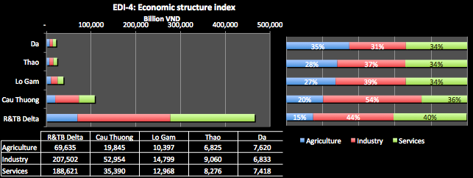
The chart shows that the GDP of the Delta sub-basin dominates the picture, where the industrial sector provides 44% of the total and agriculture provides only 15%. The Cau-Thuong is interesting as it has a very high proportion of its GDP from industry (54%) and a relatively small proportion from services (36%). The Da has the highest proportion from agriculture at 35%.

Data sources and comments
For the GDP statistics, data was obtained from the General Statistics Office of Viet Nam and from provinces. For the analysis of current GDP and GDP per capita, the current value GDP was used. For an analysis of GDP growth, GDP based on constant 1994 prices was used to remove the effects of inflation. The annual Socio-economic development from Government may be referred from reports of Ministry of Investment and Planning (MPI).
For assessing GDP growth, the project assumed an average growth rate over the most recent 5 years, expressed as a percentage. The sub-basin GDP growth was the average of GDP growth rates of all provinces in the sub-basin, adjusted for provinces that span more than one sub-basin.

6.2 Sub-sector economic indicators

Explanation of subsector economic indicators
EDI-5 is the industry sector production indicator. This shows the economic value of industrial production per unit of water used for industrial activities in the sub-basin.
This shows the economic returns (‘000 VND) in industry activities for each unit of water used as input. A high number indicates a good return for investments in industrial development. It should be noted that this indicator ascribes 100% of industrial output value to water. This will cause an over-estimated in terms of water’s value of marginal product to industry. Therefore, this indicator should not be compared to EDI-6. However, a high indicator value does show a sub-basin with significantly economic returns from industrial production per unit of water input. A high value does not necessarily reflect more efficient use of water, which is highly dependent on the industry type, the value of outputs, and its water use.
The results for the RTBRB are presented in the following chart:
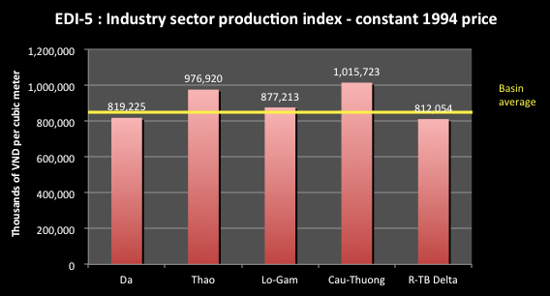

This shows that the Cau-Thuong sub-basin provides the greater economic returns for the water used in productions – over a thousand billion VND per m³. The Thao sub-basin is next. Surprisingly, the Delta sub-basin provides the lowest returns, below the Basin average, suggesting less efficient, perhaps older and antiquated, production techniques.
EDI-6 is the irrigation production indicator. This shows the value of irrigation production per unit of water used. The indicator shows the economic returns (in thousands of VND per m³ of water used) in irrigation activities for each unit of water used as input for irrigation activities in the sub-basin. It should be noted that this indicator ascribes 100% of irrigated agriculture output value to water. This will cause an over-estimated in terms of water’s value of marginal product to irrigated agriculture. Therefore, this indicator should not be compared to EDI-5. The results for the RTBRB are presented in the following chart:
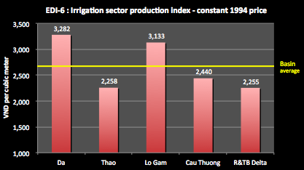
The chart shows that the Da and the Lo-Gam sub-basins provide a return of over 3,000VND per m³ of water used, well above the average for the RTBRB. This compares to the Delta at only 2,255VND per m³.
EDI-7 is the irrigation development indicator. This shows the proportion of the design area of irrigation schemes in a basin group that is currently irrigated.
The indicator shows the current development of irrigation schemes compared to their design potential. A high number indicates that the irrigation schemes are highly developed. A low number might suggest that there is a constraint to effective operation, e.g. too little water, inefficient operation, poor system management or poor design. The results for the RTBRB are presented in the following chart:
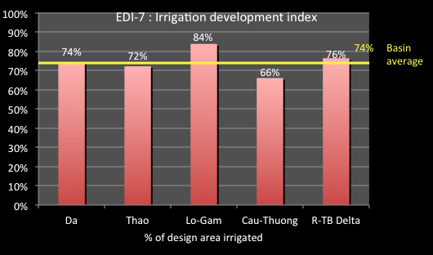
The chart shows that the area being irrigated is much less than the actual design area of the schemes, and shows that on average for the RTBRB only 74% of the design areas is being irrigated. The Cau-Thuong sub-basin has the highest level of under-use at 34%. The reasons for this under use include: funding shortfalls; water availability shortfalls (particularly for the Cau-Thuong sub-basin); under-capacity of systems; planning or design changes or deficiencies; incomplete construction of works, including lack of secondary or tertiary canal systems; system damage or degradation; and poor system operations.
EDI-8 is the current hydropower generating capacity indicator. This shows the current hydropower generating capacity as a proportion of the total hydropower generating capacity in the sub-basin. The indicator shows the percentage of the current generating capacity of the sub-basin to the basin’s total hydropower production. A high percentage indicates that this sub-basin is providing a significant contribution to the Basin hydropower generating capacity and is therefore important regionally. The results for the RTBRB are presented in the following chart:
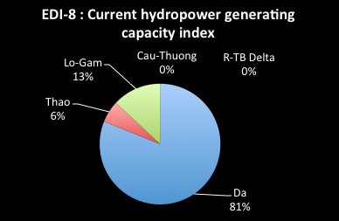
The chart shows that the majority of hydropower generated in the basin is within the Da sub-basin, at 81% of the Basin total, with the Lo-Gam and the Thao contributing lesser quantities. The other sub-basins do not produce any hydropower.
EDI-9 is the future hydropower indicator. This is similar to EDI-8, but shows the projected hydropower capacity of the sub-basin at 2025 as a proportion of the projected total basin hydropower at 2025. The indicator shows the percentage of the 2025 generating capacity of the sub-basin to the basin’s total hydropower production. The results for the RTBRB are presented in the following chart:
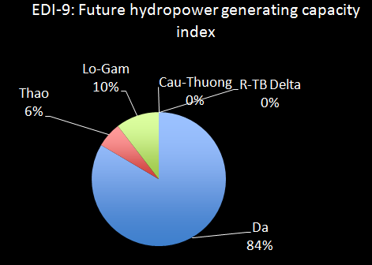
The chart shows that the Da sub-basin has increased production slightly and is still by far the major contributor to hydropower in the basin (remaining at 84%), with the Lo-Gam decreasing marginally and the Thao retaining the same generation capacity.
EDI-10 is the hydropower development index indicator. This shows the proportion of the full potential for hydropower development of the sub-basin that is currently developed, and that which may be developed at 2025 projections. The WSR found that Viet Nam has relatively small hydropower potential overall – a maximum of about 85,000 GWh a year, compared to 130,000 GWh a year for Japan, 320,000 GWh a year for India and 1,300,000 GWh a year for China. By 2025, this is expected to increase to 83%, a very high proportion the highest level of use made of its full hydropower potential. The levels of development for the sub-basins are important to assess the pressure that such development is putting on the river basin. The results for the RTBRB are presented in the following chart:
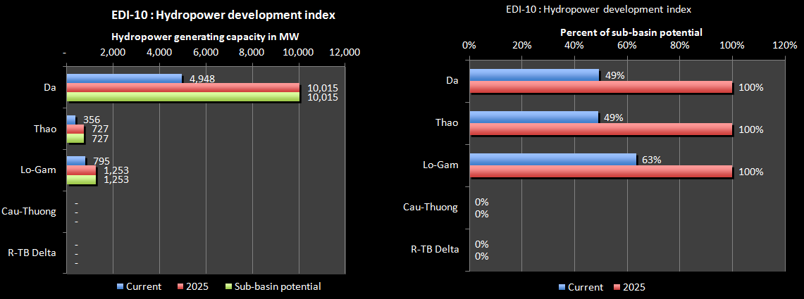
The chart shows that the Da and Thao sub-basins are currently generating less than half their hydropower potential, with the Lo-Gam generating slightly more than half. However, they are all expected to generate their full potential by 2025. For the Da, which is already heavily developed with reservoir storages, this involves an additional 6,000MW of installed hydro generating capacity.
EDI-11 is the navigation value indicator. This is economic value of inland cargo for the sub-basin as a proportion of total for the basin
This illustrates the economic value of the current sub-basin waterway transportation as a percentage of the total basin.
The results for the RTBRB are presented in the following chart:
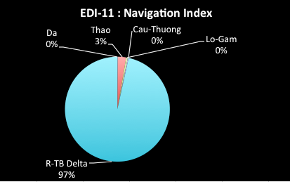
The chart shows that the Da sub-basin generates virtually all of the economic value of navigation in the basin at 97%. Only the Thao sub-basin makes a small contribution.
EDI-12 is the aquaculture indicator. This shows the economic value of aquaculture divided by the water used for aquaculture production.
The indicator highlights the economic returns (‘000 VND) from the current use of water devoted to aquaculture.
The results for the RTBRB are presented in the following chart:
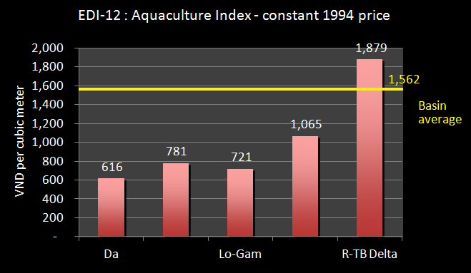
The chart shows that the Delta sub-basin has by far the greatest economic returns for each unit of water used for aquaculture production, suggesting the production of high value aquatic species. The Da, Thao and Lo-Gam sub-basins have a relatively low value of economic production per unit of water used, perhaps suggesting either production of a low value species or inefficient production techniques.

Data sources and comments
The statistics for the economic production indicators for industry, irrigation and agriculture production were obtained from the Ministry of Agriculture and Rural development and its agencies as General Department of Fishery, National Institute of Land projection and planning. Digital map of land use from General department of Land – MoNRE is good sources of data and the map is updated regularly.
The data for the irrigation development indicator may be obtained from a Study on Nationwide Water Resources Development and Management in the Socialist Republic of Vietnam, (JICA 2002). For other river basins, data may be obtained for MARD's investigation of irrigation projects.

7. Environmental indicators
The Environmental Indicators seek to show the use of natural and environmental resources of river basins, the condition of important resources, and the impacts of human activities on the natural environment of river basins.

7.1 Conservation and land use indicators
EVI-1 is the land use indicator. This shows the proportion of land area of each sub-basin used for forests, agriculture, residential, special purposes and ‘other’ uses. It indicates the way the basin land is being used, which can indicate the health of the catchments of the sub-basins and potential pressures on water resources. A high percentage of forests suggests that a sub-basin has good water retention capability and can sustain natural processes. High forest cover also suggests a less modified environment.
The results for the RTBRB are presented in the following chart:
The chart shows that in the classificaiton “other” land uses dominates the Da Lo-Gam - as much as 28% for the Da, other sub-basins “other” land uses less than 10%. These sub-basins have relatively little agricultural land. The Lo-Gam has a high forest area. Forestry makes up nearly half the land area of the Cau-Thuong sub-basin and agricultural land a further 28%. The Delta sub-basin is dominated by agricultural land, with only a small amount of forest area.
EVI-2 is the native forest indicator. This shows the proportion of sub-basin area that is native forest, and the percentage of native forest in the Basin that is within the sub-basin. A high value indicates good quality natural forests and therefore good catchment processes for water runoff and water quality. A low value may mean that there is substantial plantation forests in the sub-basin, which could be drawing on the water stored in the soil profile as the young trees grow. In some countries, a water exploitation licence is required for plantation forests recognising that they can take water out of the soil profile that would normally flow to the groundwater source.
The results for the RTBRB are presented in the following chart:
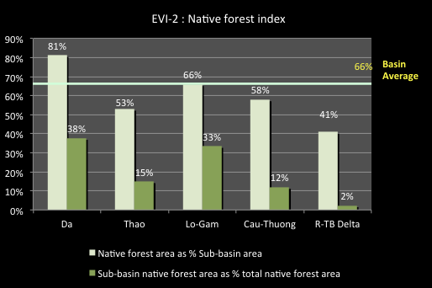
The chart shows that the Da sub-basin has by far the greatest proportion of its land as native forest area, at 81%. Because of this high percentage it is the only sub-basin above the Basin average of 66%. The other sub-basins have more that 50% of their land areas designated at native forests, except for the Delta sub-basin where it is 41%.
The Delta sub-basin also has only 2% of the total native forest area of the Basin, meaning that its land area has been extensively modified. The Da and Lo-Gam sub-basin have the bulk of the native forest area of the Basin - together they amount to nearly three quarters of the total. These are areas where greater land protection measures may be required to sustain the nature water processes for the Basin.
EVI-3 is the species indicator. This shows the number of flora and fauna species in the Red Book that have been identified in each basin. Red Book species include those that are endangered, threatened, vulnerable, near threatened, or rare. A high number suggests that a basin, or parts of it, require special care and protection as it makes a significant contribution to national bio-diversity. The results for the RTBRB are presented in the following chart:
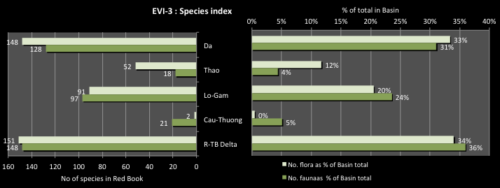
The chart shows that the Da and Delta sub-basins have the greatest number of fauna and flora listed in the Red Book, with each having around 150 species listed, each accounting for a third of the Basin total. There are much fewer flora species in the other sub-basins, with the lowest number in the Cau-Thuong (only 2 flora and 21 fauna species).
The Da and Delta sub-basins have nearly 70% of the total species of the Basin’s listed species, again emphasising their importance to the biodiversity of the Basin. For the Da this reflects the fact that this sub-basin has considerable forest cover and native forest areas. The Delta is very different and presents greater challenges with the enormous pressures on land use. In terms of the other sub-basins, all have significant proportions of the Basin total, although the Cau-Thuong has much fewer than the others. This does not mean that these sub-basins do not deserve attention; in fact, greater efforts should be made to protect the remaining species.
EVI-4 is the conservation area indicators. This shows the area of national parks, significant wetlands, other conservation areas or water related heritage area in each sub-basin firstly as a percentage of the total in the Basin as a whole, and also as a percentage of the sub-basin area. It indicates the conservation values provided by the basin. A high percentage suggests that there are large areas of special conservation value and environmental assets in the sub-basin.
The results for the RTBRB are presented in the following chart:
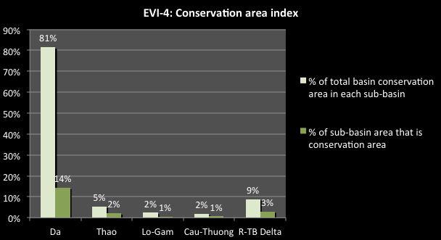
The chart shows that the Da sub-basin has the major part of its land areas occupied by conservation lands – 81%. This again emphasises the importance of this sub-basin to the biodiversity of the RTBRB. The other sub-basins have relatively small land areas used for conservation purposes – generally only a few percent.

Data sources and comments
Data for the land use indicator statistic was obtained from Digital map of land use from General department of Land – MoNRE is a good source of data and the map is updated regularly.
“Forest” includes old growth native forest, regenerated native forest and plantations. No indication of the quality of the forest is given.
“Agriculture” includes seasonal and annual crops, as well as permanent plantings, livestock raising, and aquaculture.
“Residential” includes all village and land within defined urban areas.
“Specific purposes” includes non-agricultural industrial and manufacturing land, mining, military (defence and security) land, and other ‘public’ purposes.
“Other” includes all other land, which may include lagoons and swamps, and unused land.
Data for the species indicator statistic is the number of flora & fauna species in Vietnam Red Book found in each sub-basin. Red Book species have been surveyed in protected areas and national parks, nature reserves, habitat or species conservation areas, and wetlands. Data will need to be sought from many and varied sources, such as from the Bird of Life prepared by IUCN. Provincial State of the Environment (SoE) reports may be another source. Data may not be available for some provinces. Care must be taken with the statistics found and used. To a large extent, the number of species found is a function of where studies or surveys have been undertaken. Mostly these are undertaken in conservation areas, so there is a high correlation between conservation areas and Red Book species. This does not necessarily mean, however, that these species are absent elsewhere, rather that no, or few, surveys have been undertaken.
The conservation area indicator statistics (EVI-4) are the conservation areas of each sub-basin as a percentage of the total for the Basin. Conservation areas are defined as national parks, conservation areas, and significant wetlands nature reserves and also includes water related significant heritage sites. The list of national parks and nature reserves can be taken from the Government decree on such. Area data may be sourced from Bird of Life (IUCN), and official provincial SoE reports. The list of heritage/cultural and historic sites can be sourced from the Government decree on such. “Water related” sites include forested areas, and other sites of biodiversity or conservation value, as well as those water–related sites of historic value.
The conservation areas are changed year by year depending upon the socio-economic development. The data and information may be found in the documents prepared by MARD, MoNRE, or provincial data

7.2 Water flow indicators
EVI-5 is the natural flow indicator. This shows the proportion of the sub basin area within Viet Nam that is located above major dams. It indicates the degree to which surface flows in the catchments and sub-catchments of the basin are not impacted by major reservoirs. In the areas upstream of the major dams, flows are unregulated, and are likely to be relatively “natural” in terms of their timing and variability. A high % means that a high proportion of surface runoff can be captured by dams and regulated - this suggests a low degree of natural river flows in the basin.
The results for the RTBRB are presented in the following chart:
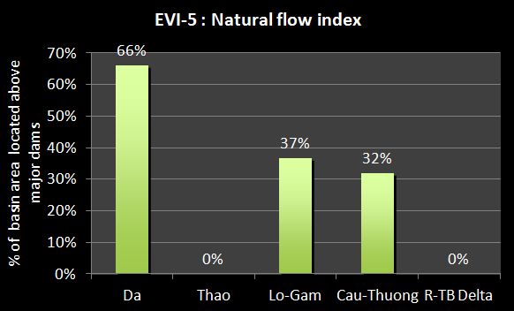
The chart shows that the reservoirs in the Da sub-basin have had a major impact on the natural flows: it has 66% of its catchment area above the major reservoirs, meaning that a high proportion of surface runoff can be captured by dams and regulated. This suggests a low degree of natural river flows in the sub-basin. The Lo-Gam and Cau-Thuong sub-basins is also a relatively high percentage. The Thao sub-basin has no reservoirs so its indicator value is zero, meaning that all of the catchment in that sub-basin are still essentially natural. While the Delta sub-basin also has a zero value as there are no reservoirs in the sub-basin, its flows are influenced by the upper sub-basins making the heavily controlled.
EVI-6 is the river obstruction indicator. This shows the ratio of rivers upstream of river structures to the total length of the main rivers in the sub-basin. This indicator shows the percentage of the length of rivers affected by a fixed blockage across the river (e.g. weir or barrage). A natural river with few structures will have a low number. A high number indicates long lengths of river above a fixed blockage (barrage, weir or dam). This will restrict movement of aquatic fish/animals. It will also reduce navigation passage.
The results for the RTBRB are presented in the following chart:
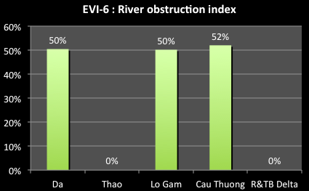
The Da, Lo-Gam and Cau-Thuong sub-basins, with a dam in the lower end of the catchment, have the highest index at around 50%. This means that access to about half of the rivers of the sub-basin is blocked by the dam. The Thao sub-basin has no dams yet so all of its rivers are fully accessible without obstruction. For the Delta, as there are no lower river obstructions all of its rivers are also fully accessible.
EVI-7 is the river level indicator. This shows the current annual minimum river height level at key sub-basin locations compared to the past levels (preferably 10 years ago). The indicator shows the drop in the minimum river flow height over 10 years and therefore, the amount of reduced flows in the rivers of the sub-basin. A low index value means that the current water level is very much lower that it used to be, resulting in far less water for water allocations, reduced navigation passage, possible non supply to some users if the current flow levels are below the off-take levels of the supply channel, and significantly reduced river health. The causes can be dam construction with no agreed low flow releases or inter-sub-basins diversions, or increased water diversions up river.
The results for the RTBRB are presented in the following chart:
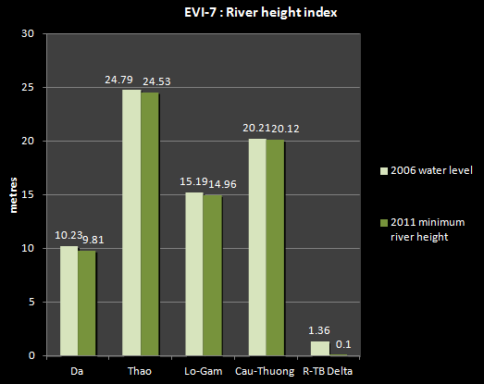

For this project, it was only possible to get river heights as far back as 2006. This shows that the major impact has been for the Delta sub-basin (the Red River at Hanoi), where the recorded lowest level dropped from 1.36 m in 2006 to 0.1 m in 2011. The records show a continuing major decline over the 5 years, which is a major concern. Such reduced flows can significantly impact on river health, particularly as the river receives much of Hanoi’s untreated wastewater, and as waterway navigation in this location is an important part of the economy. This result requires urgent assessment to determine the causes and the impacts.
The other sub-basins all show small reductions in the lowest recorded flows over the 5 years. However, given the short length of record it is not possible to make any firm conclusions.

Data sources and comments
Data on the annual minimum river height at key locations was obtained from the General Statistics Office, available from:
http://www.gso.gov.vn/default_en.aspx?tabid=466&idmid=3&ItemID=12821
The GSO records the deepest levels and the shallowest levels at key locations. A comparison of the shallowest levels over time was used for this indicator. Flow heights were used as follows: the Da River – flow heights at Hoa Binh; the Thao River at Yen Bai; the Lo River at Tuyen Quang; the Cau River at Thai Nguyen; and the Red River at Hanoi.
The natural flow indicator statistic requires data on the sub-basin area above major dams. This area includes catchment areas of all tributaries without major dams that flow into the main river upstream and downstream of the uppermost major reservoir on the main river, as well as the catchment area of the main river upstream of the uppermost major reservoir on the main river. The sub-basin area above major reservoirs excludes the catchment area of all tributaries that themselves have major dam reservoirs, and flow into the main river upstream and downstream of any major reservoir on the main river. Major reservoirs have been defined as having storage of greater than 1 million m³. Data on the location and size of reservoirs was sourced from Master Plan Study on Hydropower Development in Vietnam – Period 2001-2010 and perspective up to 2020 (Ministry of Industry), and from various project documents on water resources development (from MARD).
The river obstruction indicator statistic, data on the total length of rivers in each basin can be sourced from Characteristics of River Morphology in Viet Nam (General Office of Hydrometeorology, 1985). Length of river above fixed structures data can be calculated from various sources, including the Inland Waterway Administration (Ministry of Transportation), and Master Plan Study on Hydropower Development in Vietnam – Period 2001-2010 and perspective up to 2020 (Ministry of Industry). A fixed structure is defined as un-gated dams, weirs and barrages. The planner should understand all the sector development planning, especially hydropower development and irrigation and drainage development planning.
River height data may be sources form the National Centre for Hydro-Meteorological Services (http://www.nchmf.gov.vn/web/en-US/67/96/Default.aspx
General information on rivers from: Department of Water Resources Management – Decision 1989/QD-TTg dated 1 November 2011: http://dwrm.gov.vn/index.php?language=vi&nv=laws&op=Tai-nguyen-nuoc/Danh-muc-luu-vuc-song-lien-tinh.

7.3 Water quality indicators
EVI-8 is the biological water quality indicator. In the guidelines this is the ambient water quality for BOD5 divided by the corresponding values (Class B) - QCVN 08:2008/BTNMT National technical regulation on surface water quality. However, in the case as there were quite a few water quality results to display, it was decided to show the recorded values with the B1 standard values also shown.
The indicator shows the recorded BOD level compared to the Standard - BOD indicates the amount of organic pollutants found in surface water. Standard: B1 class ≤ 15 mg/l. A high score indicates waters low in dissolved oxygen, which can lead to increased release of phosphorus from sediments that can fuel algal blooms.
The results for the RTBRB are presented in the following chart:
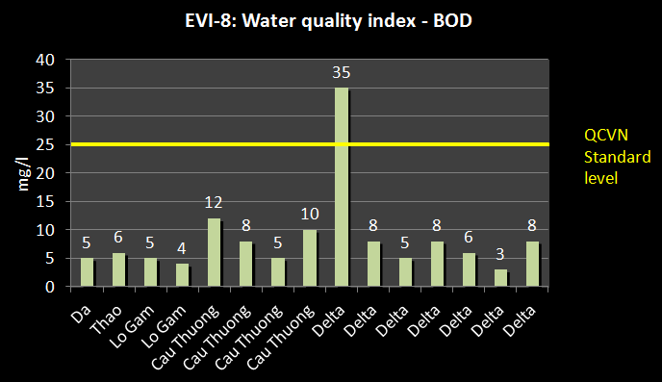
The chart shows that the standard is met with only one exception, which would be in the Red River near Hanoi. Readings are generally higher in the Cau-Thuong and the Delta sub-basins.
A number of other plots were also made to consider other water quality parameters, as follows.
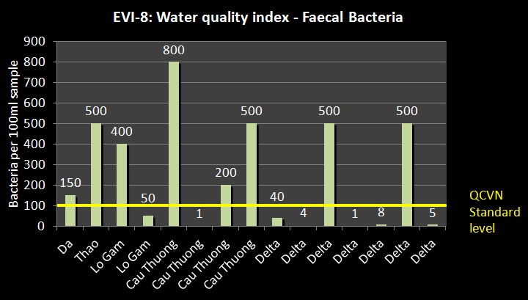
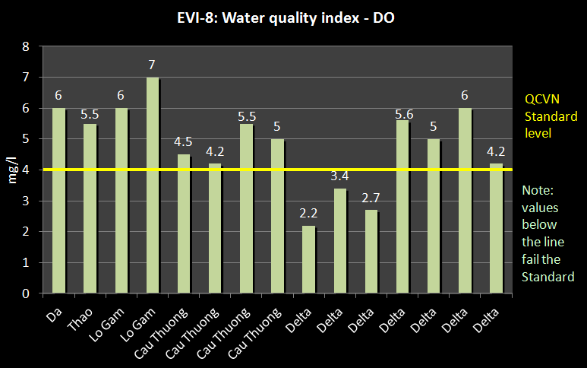
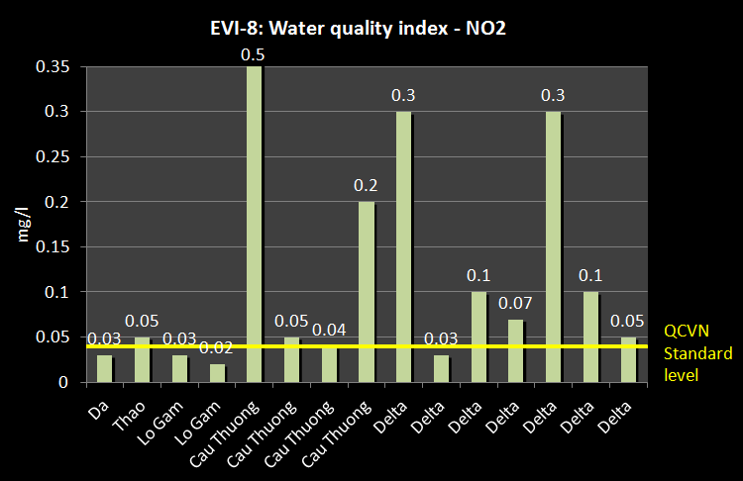
The charts show that the B1 Standard are not met in many parts of the sub-basins and in fact is exceeded by significant factors. The Cau-Thuong and the Delta sub-basins generally have the highest readings, clearly caused by the considerable amount of urban settlement in the sub-basin and the agricultural and industrial activities. Nutrient runoff to the river is a clear cause of concern. The degraded nature of the river system also limits the ability of the river to cope with the nutrients levels.
EVI-9 is the domestic wastewater treatment indicator. This is the proportion of treated domestic water and the level of treatment. This indicator identifies the proportion of domestic wastewater treated before discharge, and the level of treatment (primary or secondary). A low score for domestic wastewater, and a low S score, indicates a high potential for pollution and the addition of organic or other pollutants to the water source. It is assumed that there is no tertiary treatment.
The results for the RTBRB are presented in the following chart:
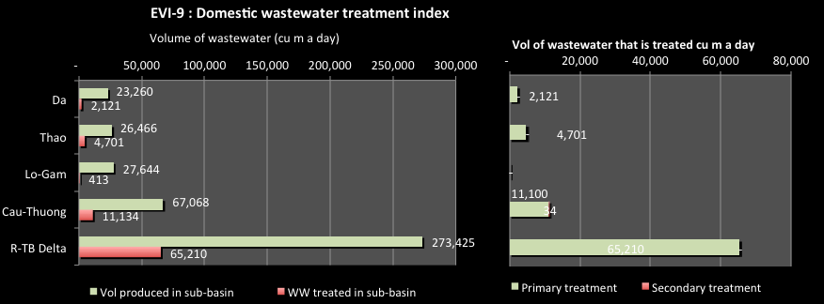
The chart shows, not surprisingly, that the Delta sub-basin generates the greatest volume of wastewater – some 273,425 m³ a day. Of this only about 65,000 m³ a day is treated. The Cau-Thuong also generates a consdierable volume of domestic wastewater each day, with only a fraction treated. Of the wastewater that is treated, the vast majority is treated to the basic primary level, and only a few percent receives secondary treatment. This demonstrated the serious levles of polluted water that is discharged to water suources each day.
EVI-10 is the hospital wastewater treatment indicator. This is the proportion of treated hospital wastewater and the level of treatment. This indicator shows the proportion of wastewater treated before discharge and the level of treatment. A low score for hospital wastewater, and a low secondary treatment score, indicates a high potential for pollution and the addition of organic or other pollutants to the water source. Untreated hospital waste can lead to serious health consequences in the local community.
The results for the RTBRB are presented in the following chart:
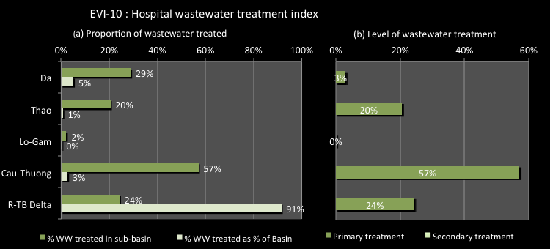
The chart shows that across the RTBRB, generally less than a third of the hospital wastewater generated in the sub-basins is treated before discharge. The exception is the Cau-Thuong where 57% of the wastewater is treated. All of the treatment is for primary treatment only – there is no secondary treatment
EVI-11 is the industrial wastewater treatment indicator. This is the proportion of industrial wastewater in each sub-basin that is treated before discharge to a water source, and the level of treatment (P=primary, S=secondary, T=tertiary).
The indicator shows the proportion of wastewater treated before discharge and the level of treatment. A low score for industrial wastewater, and a low T score, indicates a high potential for pollution.
The results for the RTBRB are presented in the following chart:
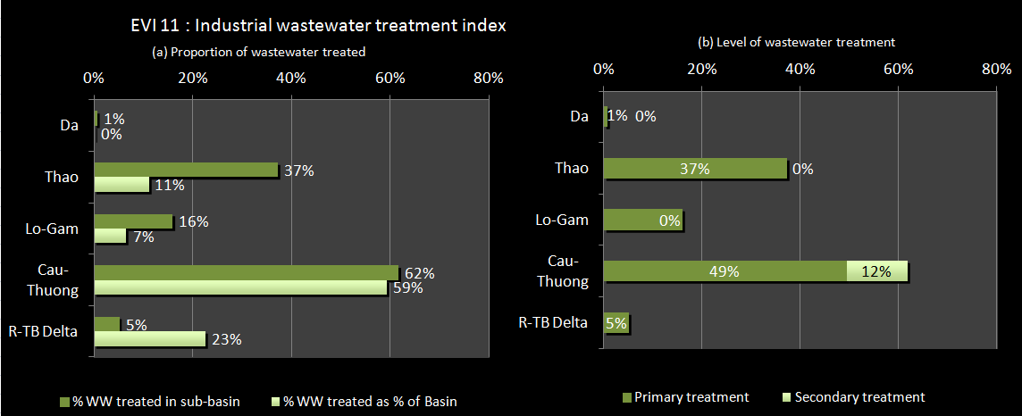
The chart shows that most of the industrial wastewater treatment is in the Cau-Thuong sub-basin, where 62% is treated. This makes up 59% of the total wastewater treated in the RTBRB. As well, 12% of the wastewater is treated up to secondary standard. In the Delta sub-basin, only 5% of the wastewater is treated before discharge to a water source, all to primary level only.
EVI-12 is the solid waste indicator. This shows the proportion of solid waste that is collected and disposed of in urban and rural areas. This indicator highlights the proportion of solid waste that is collected and not simply dumped at random. A low percentage indicates a high potential for pollution as most solid waste is dumped near water sources, and/or can find its way to a river, lake or groundwater. The results for the RTBRB are presented in the following chart:
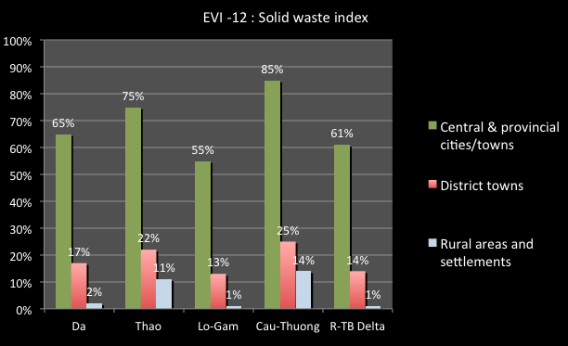
The chart shows that the proportion of solid waste collection is much greater in central and provincially controlled cities and towns (55% to 85%), while small percentages are collected in district towns (14% to 25%), and extremely low percentages of solid wast are collected from rural areas. The Cau-Thuong sub-basin has better results than the other sub-basins.

Data sources and comments
The data and information related water quality is found in many agencies. Data and information may be available in the General Department of Environment Protection - MoNRE with recent records at different sites. Some hydro-meteorological observation stations may have some information related to water quality, but only a few parameters. In addition, information from factories or industrial areas supplied to MoNRE for monitoring is a good source.
Sampling data for environmental monitoring was also obtained from the Center for Environmental Monitoring under VEA within MoNRE.
BOD₅ concentration results should be from monitoring stations in main rivers of the sub-basins (not in lakes or reservoirs), in an attempt to represent the general ambient water of the sub-basin rivers. Results from monitoring stations should be excluded if they are impacted by a known point source pollution discharge (stations in the sewage discharge channels and stations located immediately after a known discharge point, where the water is not yet fully mixed).
In some cases, there may be significant differences between data from the national and local monitoring systems. Data from the national monitoring programme should be used as the first preference, as they are considered more reliable given that the monitoring activities have been carried out for more than 10 years by competent agencies.
The domestic wastewater treatment statistic is the domestic wastewater treated in basin/domestic wastewater generated in sub-basin expressed as a percentage. The domestic wastewater treated the total capacity of domestic wastewater treatment plants of provinces in the sub-basin. Data for domestic wastewater treatment plant capacity can be sourced from provincial Water Supply and Sewerage Companies (WASECOs). The domestic wastewater generated may have to be computed from domestic water use figures, assuming that 80% of water used becomes wastewater. Domestic water use can be taken to be 100 litres per person per day for urban areas, and 50 litres per person per day for rural areas.
The hospital wastewater treatment statistic is the hospital wastewater treated in basin/hospital wastewater generated in sub-basin expressed as a percentage. The hospital wastewater treated the total capacity of hospital wastewater treatment plants of provinces in the sub-basin. Data for hospital wastewater treatment plant capacity may be sourced from the Viet Nam Water Supply and Sewerage Association, or the Ministry of Health. The hospital wastewater generated may be computed assuming that each patient bed generates 500-600 litres of wastewater per day (600 litres in major cities and 500 litres elsewhere), based on the methodology used by VWSA. Provincial data for hospital bed numbers can be sourced from GSO, adjusted for provinces in more than one sub-basin. There is anecdotal evidence that some hospital wastewater treatment facilities are not being operated all the time or to full capacity due to a lack of funding for operating costs.
Data on industrial effluent may be difficult to source. The Master plan for Industry development and Infrastructures for 1996-2010 approved by Government – Decision 519/TTg dated 6/8/1996, may be useful. Contact with the Ministry of Industry and Trade or the Provinces may be required.
The solid waste collection statistics are the solid waste collected and disposed of in cities and towns, District towns and rural areas in each sub-basin, expressed as a percentage. The solid waste collected the total solid waste as measured at disposal sites in the sub-basin. Data for solid waste measured at disposal sites may be sourced from urban environmental companies. The solid waste generated may be computed assuming an average amount of waste generated per person per day of 0.7kg/per/day for cities and towns, and 0.3kg/per/day for rural areas. It should be noted that collection and disposal at a designated site does not necessarily mean that the waste is being disposed of in a socially or environmentally benign manner, just that it is centrally disposed of. Of the waste that is disposed of in a designated disposal site, the bulk is taken to the thousands of above ground, non-sanitary dumpsites around the country, which themselves pose a not insignificant risk to human health, both directly, and indirectly via pollution of soils, surface water, and groundwater resources.

8. Water Management Indicators
The Water Management Indicators seek to show the effectiveness of water resources management across some of the key sectors. In this context management includes the collection of data and information for effective decision making, using environmental instruments such as EIAs, licensing, efficient provision of services and human capacity.

8.2 Basic survey indicators
WMI-1 is the recorded streamflow indicator. This is the number of Level 1 gauging stations (National) in the sub-basin, and the number of years of record at the station with the most years. This indicator shows the extent of recorded river flow information in the sub-basin. The higher the number, the greater the confidence in the assessment of river flows. The results for the RTBRB are presented in the following chart:
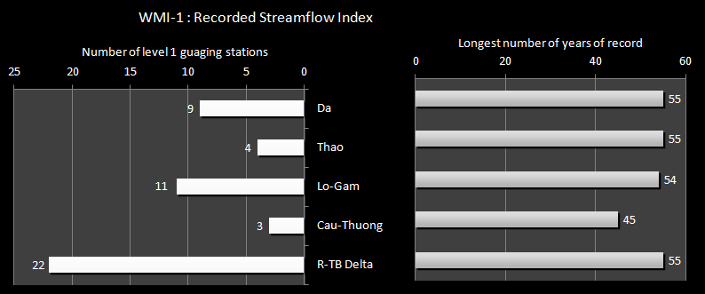
The chart shows that the Delta sub-basin has the most National level monitoring stations (22), which have records for up to 55 years. However, the Cau-Thuong only has 3 National stations which may be an issue as its water resources are so few compared to the current water demands. As well, the Thao has only 4, which may be an issue as this is an international river. Monitoring of flows from China could be important. Overall, the stations should be able to provide a reasonable long-term assessment of the surface water resources in the RTBRB, although there may be river sections that are not adequately covered.
WMI-2 is the overall groundwater assessment indicator. This is the percentage per total exploitation reserves of aquifers in the sub-basin assessed in each class (A, B, C) of investigation standard. It indicates the quality of assessment of the exploitation reserves of the aquifer, based on the 3 classes of assessment, thus providing an understanding of the reliability of the information provided from the aquifer. The bore holes in Class A and B are in the area with good investigation with the geo-hydrology map 1/25,000 - 1/10,000 scale and multiple pumps, therefore, the reserve can be assessed as good. Bore holes in Class A are undertaken with suction pumping over a long time and with the draw down in water level within allowable limits. Bore holes in Class B are with a single pump or extrapolated from bore holes in Class A in the same region. Bore holes in Class C1 are based on a simple suction pump over a short time. The results for the RTBRB are presented in the following chart:
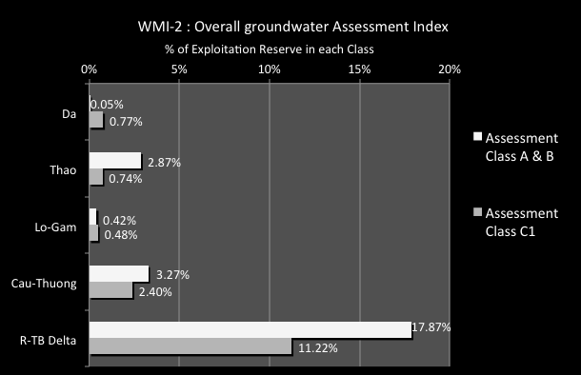
The chart shows that the majority of sub-basins have little of the assessed exploitation reserve assessed in Class A or B – less than 1% for some sub-basins, and only a few percent for others. The exception is for the Delta sub-basin where nearly 18% of the assessed exploitation reserve assessed is in Class A or B, and 11% is in Class C1. Overall, this means that the understanding of the groundwater resources of the RTBRB is based on assessments made from only very limited detailed technical information.
WMI-3 in the monitoring bore indicator. This is number of National level monitoring bores installed per sub-basin and the number of years of record at the bore with the most years. This indicator shows the extent of recorded groundwater information in the sub-basin. The higher the indicator value, the greater the confidence is in the assessment of groundwater resources. A high number in an area not suffering from over-exploitation of pollution may be a poor investment. On the other hand, a low number in areas where water tables are dropping, or where there is a growing area of saline water, will show poor management decisions. It also broadly suggests where the monitoring bores are located - the sub-basin - which can be compared to the groundwater resource situation. The results for the RTBRB are presented in the following chart:
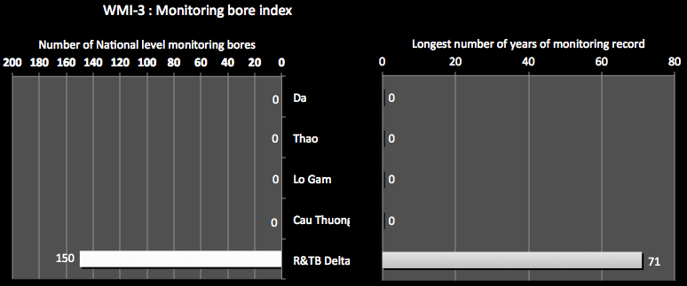
The chart shows that there is no data for 4 of the 5 sub-basins. It also shows that the Delta has 150 monitoring bores and has been keeping records for a considerable time – over 70 years at at least one station. This should provide reliable information for this the sub-basin, although considerationof WMI-3 suggests otherwise.

WMI-4 is the environmental monitoring indicator. This is the number of installed sites for environmental monitoring.
This indicator shows the potential for assessing the overall health of water sources in the sub-basin and to assess the impacts of human activities. A higher number indicates a greater potential to properly assess water source health. These are particularly important to provide an assessment of a healthy and productive river system. The results for the RTBRB are presented in the following chart::
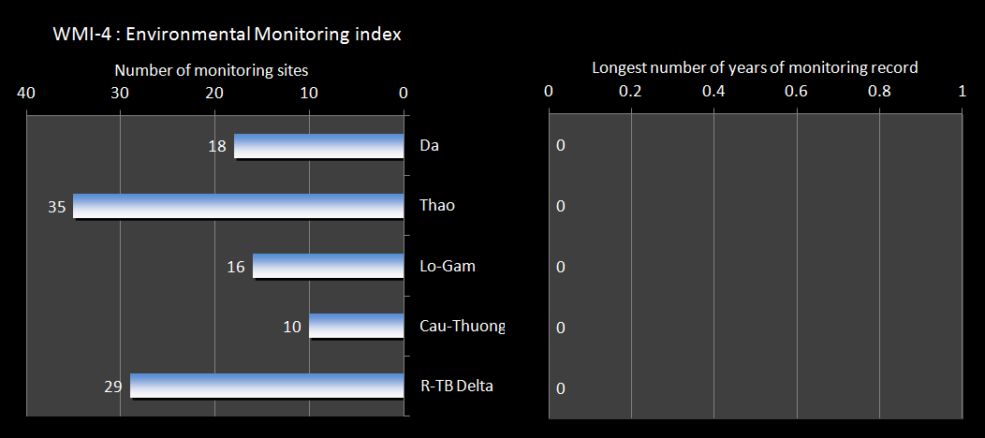
The chart shows that while all sub-basins have a reasonable number of monitoring sites; it is unknown how long records have been kept.

Sources of data
Decision 526/2012 – VEPA: Number of observation sites on Water environment 2012-2016
Centre of Meteor-hydrological Forecasting
Decision 16-2007 - Approval on "Master Plan on Natural Resources and Environment by 2020". Annex I-1: List of hydrological station by 2020
Data from DONREs.

8.2 Licensing indicators
WMI-5 is the Central licensing indicator. The number of licences for the basin issued by MoNRE for surface water extraction , groundwater extraction, and wastewater discharge. This indicator shows the extent of licensing activity for the Basin undertaken at the central level - for major licences. The higher the number the greater the likelihood that major impacting activities are coming under regulatory control
The results for the RTBRB are presented in the following chart:
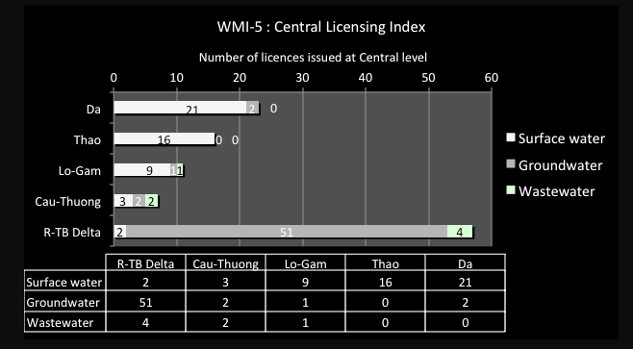
MoNRE has issued a total of 114 licences at Central level for major activities (51 for surface water, 56 for groundwater and 7 for wastewater discharge). The chart shows that surface water licensing activities are concentrated on the Da sub-basin where 21 surface water licences have been issued; and groundwater licensing is dominated by the Delta sub-basin (51 licences issued). However, only 7 wastewater licences have been issued, with most of those in the Delta. It is notable that the Central level activities have not issued more wastewater discharge licences. Few licences have been issued in the Cau-Thuong sub-basins, which is one suffering a good deal of stress.
WMI-6 is the Provincial licensing indicator. This the number of licences for the basin issued by Provinces for surface water extraction (SW), groundwater extraction (GW), and wastewater discharge (WW). It indicates the extent of licensing activity for the Basin undertaken at the provincial level. The higher the number, the greater the likelihood that major impacting activities are coming under regulatory control. The results for the RTBRB are presented in the following chart:
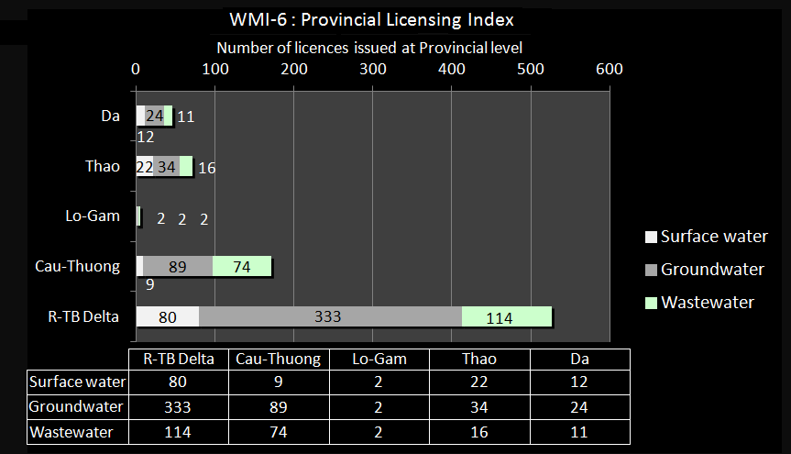

The Provinces have issued a total of 824 licences (125 for surface water, 482 for groundwater and 217 for wastewater discharge). The chart shows that all of the licensing activities have concentrated on the Delta sub-basin where 80 SW, 333 GW and 114 WW licences have been issued. Next is the Cau-Thuong with 9 SW, 89 GW and 74 WW licences. The chart shows that there have been few licences issued in the other sub-basins, particularly the Lo-Gam.

Data sources and comments
Date for this section must be obtained from MoNRE and the Provinces in the Basin, split into the various sub-basins. MoNRE may be the main sources of information through the license issued (at central level) and reported from DONRE (provincial level).

8.3 Environmental tools indicator
WMI-7 is the Decision 64 Index. This is the number of pollution establishments in the sub-basin listed in Decision 64 that has been completed (effectively dealt with), are in the process of treatment, or have not yet been dealt with. Decision 64 represents the Government’s commitment to thoroughly deal with all major polluting establishments. These establishments are listed in the Decision, which is periodically updated, and it is the Provinces responsibility to deal with the pollution. A high completed or processing number means that Provinces in the sub-basin have moved quickly to deal with the most polluting establishments. A high ‘not dealt with’ number means that provinces will need to work hard to meet the requirements of the Decree.
The results for the RTBRB are presented in the following chart:
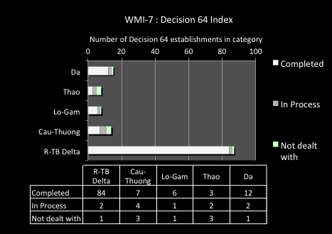
The shows that all sub-basins are making some progress regarding Decision 64, with significant numbers of polluting establishments dealt with. . However, there are still many not dealt with and it is likely that these are the older most polluting enterprises, possibly state owned, which are proving more difficult to deal with. Greater action appears to be required in the Thao sub-basin.
WMI-8 is the pollution fees indicator. It is the total value of pollution fees collected under Decree 67/2003 and the proportion of this from urban and industrial polluters.
This indicator shows the use of economic tools (based on Decree 67) for pollution control, particularly for the industrial component. A high value generally means that pollution fees are being levied by the Provinces. However, a low I value means that most of the fees are being set on urban water users and not many industries are exposed to economic tools.
The results for the RTBRB are presented in the following chart:
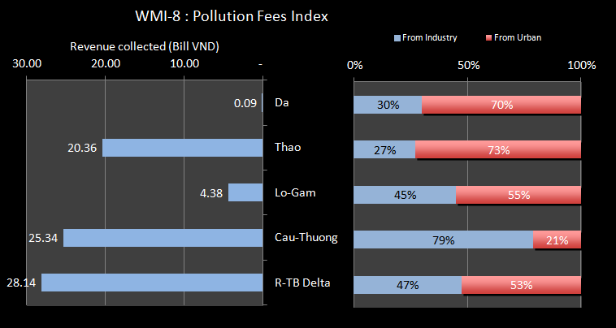
The chart shows that revenue is collected in each sub-basin, with the most being in the Delta. However, the amount collected there is relatively small compared to the other sub-basins and to the high number of polluting businesses in the sub-basin. As well, only about half of the revenue is from industry, with the rest form towns, whereas the polluting loads form industry are likely to be more significant on environmental health. In the Cau-Thuong sub-basin, the revenue collected is almost as much as for the Delta, and certainly would be way in excess of that on a per capita basis. Also, nearly 80% of the revenues is from industry. The situation in the Thao sub-basin shows considerable revenue collected, with most coming from the urban residents. Much more attention would appear to be required for the application of this instrument in the Lo-Gam and the Da sub-basins.
WMI-9 is the urban pollution fee rate indicator. It is the total value of pollution fees collected under Decree 67/2003 from urban centres divided by the urban population.
The indicator shows the scale of the financial impact of the pollution fees per person and can be used to compare the fees in one sub-basin to another. A high level of revenue per person means that fees are most likely being levied effectively by the Provinces. However, a low value per person means that Provinces are not using the economic instruments effectively.
The results for the RTBRB are presented in the following chart:
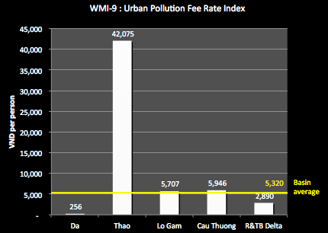
The chart shows that the Thao results are far above those of the other sub-basins. If that sub-basin can apply such fees without undue impact on the residents or its industry, then it should be possible to apply a similar approach in the other sub-basins. The Delta sub-basin has the second lowest of all the sub-basins, and the Da situation is paltry.

WMI-10 is the EIA indicator. This is the total number of EIA reports assessed and approved and the number of registration forms issued to establishments that achieve environment standards. It indicates the number of establishments that have been subject to assessment by the regulatory authorities. A high value means that enterprises that may have a significant effect on the environment have been assessed by specialists and approved, subject to conditions. The results for the RTBRB are presented in the following chart:
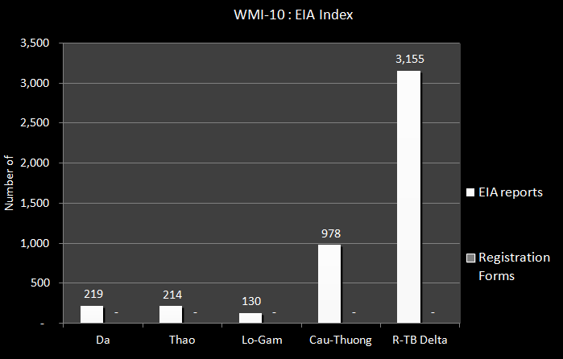
This shows that most of the EIA reports are in the Delta sub-basin, over 3,000, and the Cau-Thuong sub-basin, nearly a thousand. This is where most of the economic activities are being undertaken. In the other sub-basins the EIA reports are relatively few in number. Data on the registration forms for achieving environmental standards could not be obtained across all sub-basins.
WMI-11 is the industrial zone EIA indicator. This is the percent of Industrial Zones with EIA reports (Re) assessed and approved. Industrial zones can have major effects on surface water and groundwater resources and on human health if not planned and implemented effectively. The indicator shows the proportion of Industrial Zones that have been subject to assessment by the regulatory authorities. A high % means that most Industrial Zones have been assessed by specialists and approved, subject to conditions. The results for the RTBRB are presented in the following chart:
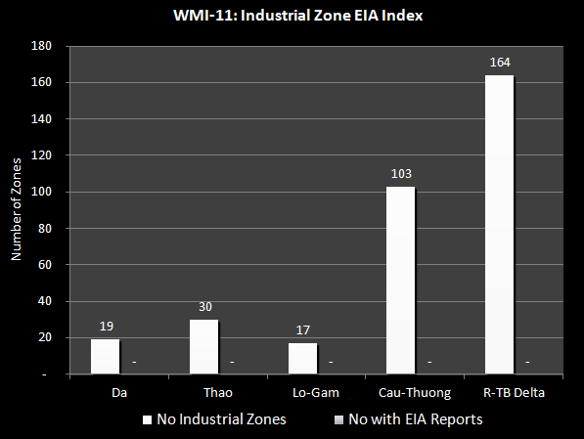
It was not possible to get the information on the industrial zones with EIA reports. Therefore, all this shows is the number of industrial zones in the sub-basins. This is dominated by the Delta (164) and Cau-Thuong (103) sub-basins, and demonstrates one major potential causes of stress in the sub-basins.
WMI-12 is the inspection indicator. This is the number of inspections a year of businesses to ensure compliance with EIA conditions or licensing conditions, compared to the number of EIA reports and licences issued in the sub-basin. It indicates the extent to which the regulatory authorities inspect businesses to ensure compliance with approval conditions. A high number of inspections compared to EIA reports and licences issued means that there are regular inspections for compliance with conditions. A low number means that compliance is rarely inspected.
The chart generated for this indicator is as follows, and it also includes the number of licences issued and EIA reports approved, to provide a context for the inspections.
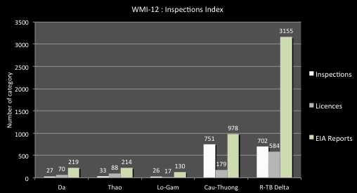
This shows that there are relatively few inspections across the Basin, 1,539 in total, compared to the number of EIA reports (around 4,700) and number of licences issued (over 900). For the sub-basins, the Delta and Cau-Thuong have the greater number, although the Cau-Thuong appear to be in better proportion – the inspections are in the order of the numbers of reports and licences issued meaning that they are inspected about once a year. However, the Delta sub-basin the inspections are much less than the licences and reports issued meaning inspections at a frequency of much greater than once a year. The other sub-basin also show inspections not in keeping with number of EIA reports and licences issued.

Data sources and comments
Date for this section must be obtained from MoNRE and the Provinces in the Basin, split into the various sub-basins. The information may be from the Provincial Board of Industry zone Management or from Sector Studies (if any).

8.4 Efficient service provision indicators
WMI-13 is the urban cost recovery indicator. It is the percentage of the average yearly costs of urban water services that are recovered through revenue. It indicates the cost recovery level for urban water services and the potential for financial sustainability. A high percentage means that subsidisation is minimal, consumers are receiving proper price signals and service provision is increasingly sustainable. A low percentage means that the service providers are being heavily subsidised by Central Government or Provinces, there is insufficient funds for maintenance or to expand services as required as populations grow, and water users have no price signals to use water efficiently.
The results for the RTBRB are presented in the following chart:
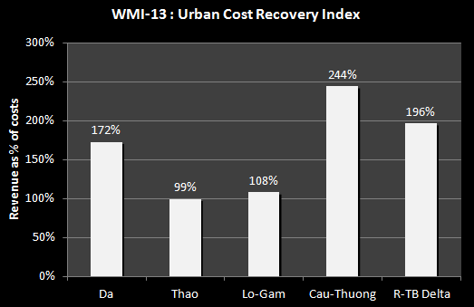
This shows that the revenue collected by the urban water supply companies is at least equal to their costs, and in the case of the Cau-Thuong sub-basin is 2.4 times the costs, and the Delta is twice the costs. However, while this may appear a strong financial position it must be remembered that while the costs are rising all the time, the water tariffs are only changed every 5 years. In this situation, the revenues for the Lo-Gam and Thao sub-basin appear too low.
WMI-14 is the urban water efficiency indicator. It is the percent of water losses in the supply system, or the “unaccounted for water” or “non-revenue water”. It indicates the efficiency of service delivery. A high % means that significant proportions of high cost treated water are lost in the system and a significant revenue loss. The results for the RTBRB are presented in the following chart:
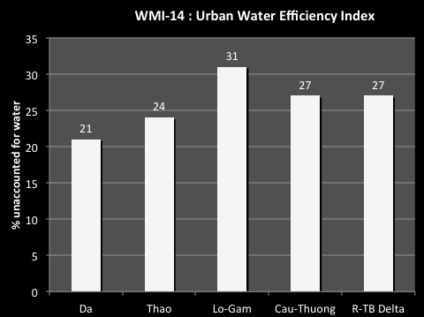
This shows that the non-revenue water in the sub-basins, while significantly improved over recent years, is still well above international standards (from 10% to 13%). The Delta sub-basin includes Hanoi where it will be difficult to significantly reduce the water losses in the short term as the systems are very old and spread out, and the cost of pipe replacement is greater. The high water losses in Lo-Gam need greater attention.

Data sources and comments
The information was referred from International study of Volume 03, Study on Water supply, Drainage and Sewerage – Urban Environmental management in Viet Nam (JICA); The Report of Viet Nam Water and Sanitation Sector Assessment (WHO, Unicef, and MoH); Report on Benchmarking Study (VWSA: Viet Nam Water Supply and Sanitation Association); Key Performance Indicators from ADB/SEAWUN report year 2005 (published 2007). Data for the urban efficiency indicators may be sourced from Viet Nam water supply and sewerage association annual reports (VWSA), from the regular benchmarking survey of companies carried out by VWSA, and from Provincial water supply companies.

8.5 Capacity indicators
WRI-15 is the WRM human capacity Indicator. This is the number of people working on water resources management (i) per 1 million people in the basin group and (ii) per thousand square kilometres of the basin group area. The number of people working on water resources management is assumed as the total number of people working on any aspect of water resources, less those working on irrigation, on urban water and on rural water supply and sanitation. This indicator shows the extent of human resource capacity in the basin engaged in water resources management, compared to the population putting pressure on the water resources, and the physical areas involved. A high number indicates good capacity to manage water resources on a sustainable basis and to respond to any major issues as required. A low number means that there is little chance that IWRM principles are being applied and water management decisions may prove not sustainable.
The results for the RTBRB are presented in the following chart:
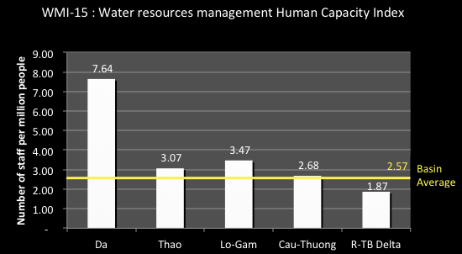
This shows that Da sub-basin has the highest number of staff for the population, at 7.64. The lowest is the Delta sub-basin, at only 1.87. The other sub-basins are only at around 3 staff per million people in the sub-basin.
WRI-16 is the WRM financial capacity Indicator. This is the value of the state/provincial budget applied to water resources management (i) per 1 million people in the basin group and (ii) per thousand sq. km of the basin group area. The value of the state/provincial budget applied to water resources management is assumed as the total budget for any aspect of water resources, less that for irrigation, for urban water and for rural water supply and sanitation. This indicator shows the extent of financial capacity in the basin group engaged in water resources management compared to the population putting pressure on the water resources, and the physical areas involved. A high number indicates good capacity to manage water resources on a sustainable basis and to respond to any major issues as required. A low number means that there is little chance that IWRM principles are being applied and water management decisions may prove not sustainable.
The results for the RTBRB are presented in the following chart:
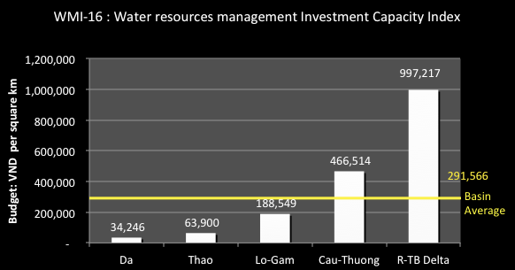
This shows that the budget for water resources management per area to be managed is highest by far for the Delta sub-basin, at nearly a million VND per km². The Cau-Thuong is less than half that figure and the other sub-basin even less. The Da sub-basin is only at around 35,000 per km².

Data sources and comments
Date for this section must be obtained from MoNRE and the Provinces in the Basin, split into the various sub-basins.

Based on the Falkenmark Water Stress Indicators
Note that the dry season trigger levels for water availability are different to those shown in Error! Reference source not found. (which is for the annual situation). The dry season levels are: 2,500 cm m per capita for adequate water, 1,062.5 for shortages, 625 for scarcity and 312.5 for a threat to life.
UNU-INWEH and McMaster University (Canada), 2012
GDP is expressed in terms of either current or constant prices. Constant price GDP is different to current price GDP, as the former removes price effects such as inflation. In Vietnam, the base year to calculate constant prices is 1994.

